**Amazon Web Service [Stage-4]**

**SUBHODEEP SEAL [897005]**

**Day 68**

**EC2 Hands-On**

Create an EC2 instance, connect to it from your local system and install apache web

server on the EC2 instance.

Created instance

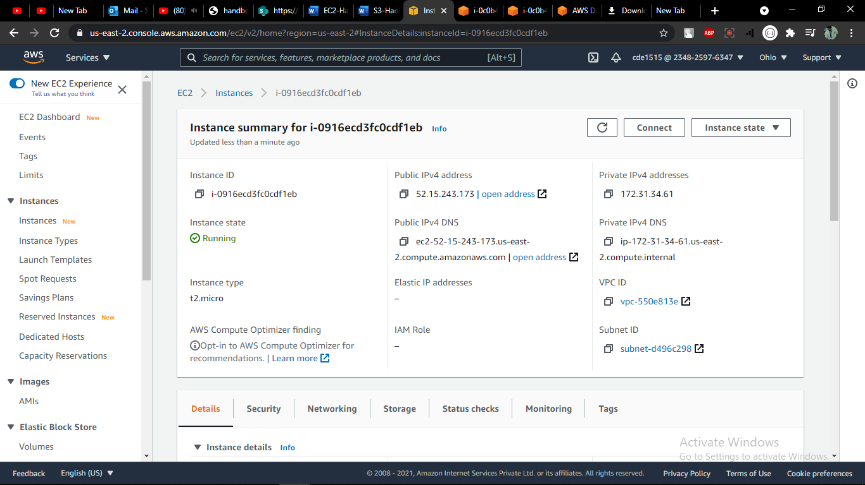

Connected to instance to install apache server

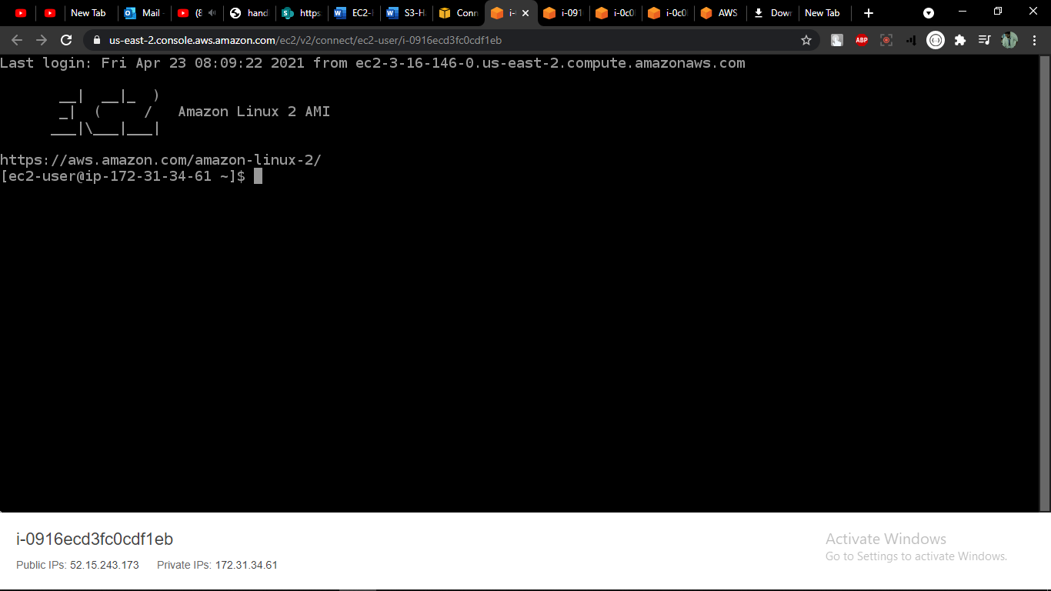

Edit inbound rules

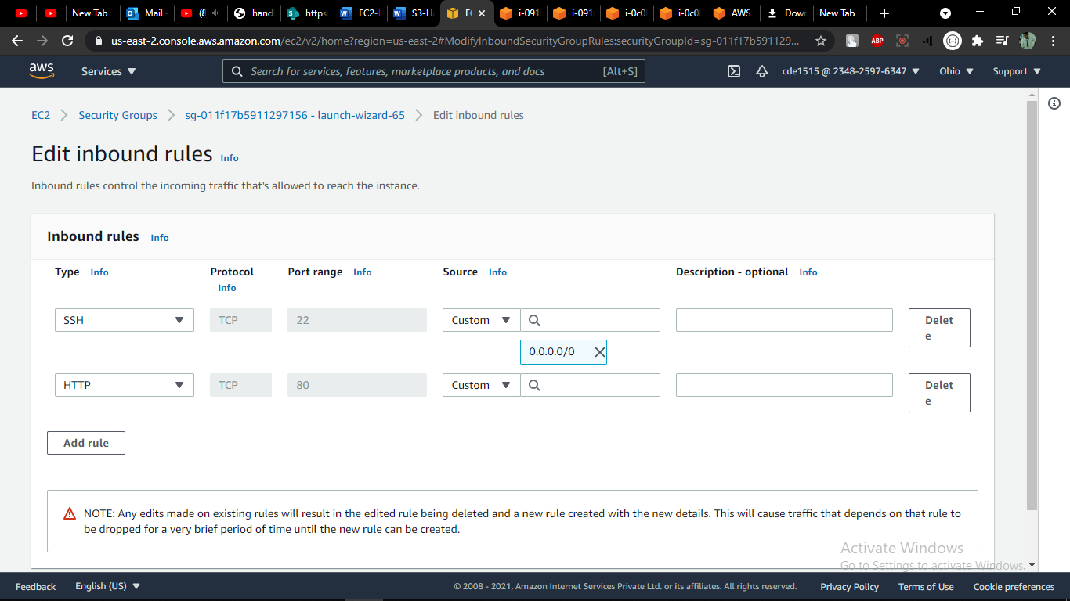

Open the PUBLIC IPv4 URL to test apache

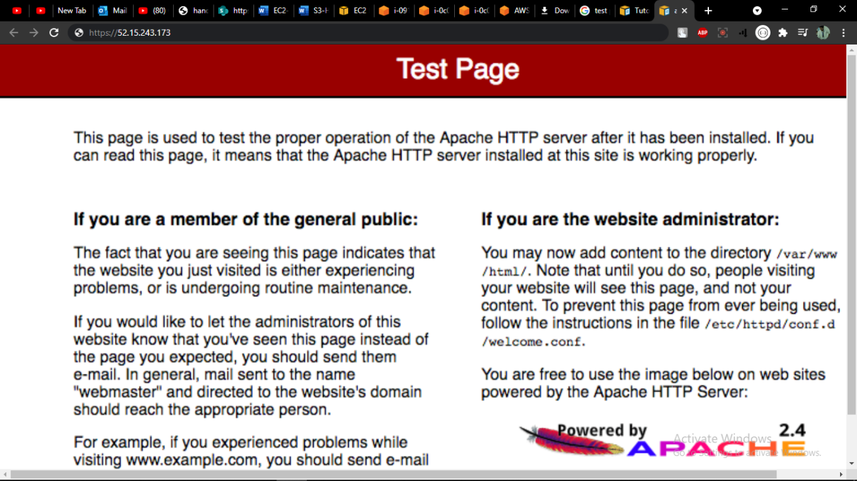

**S3 Hands-On**

Create a S3 bucket and store an object in it. Enable to object for public access so that

anyone can access it through a web browser.

Created a bucket

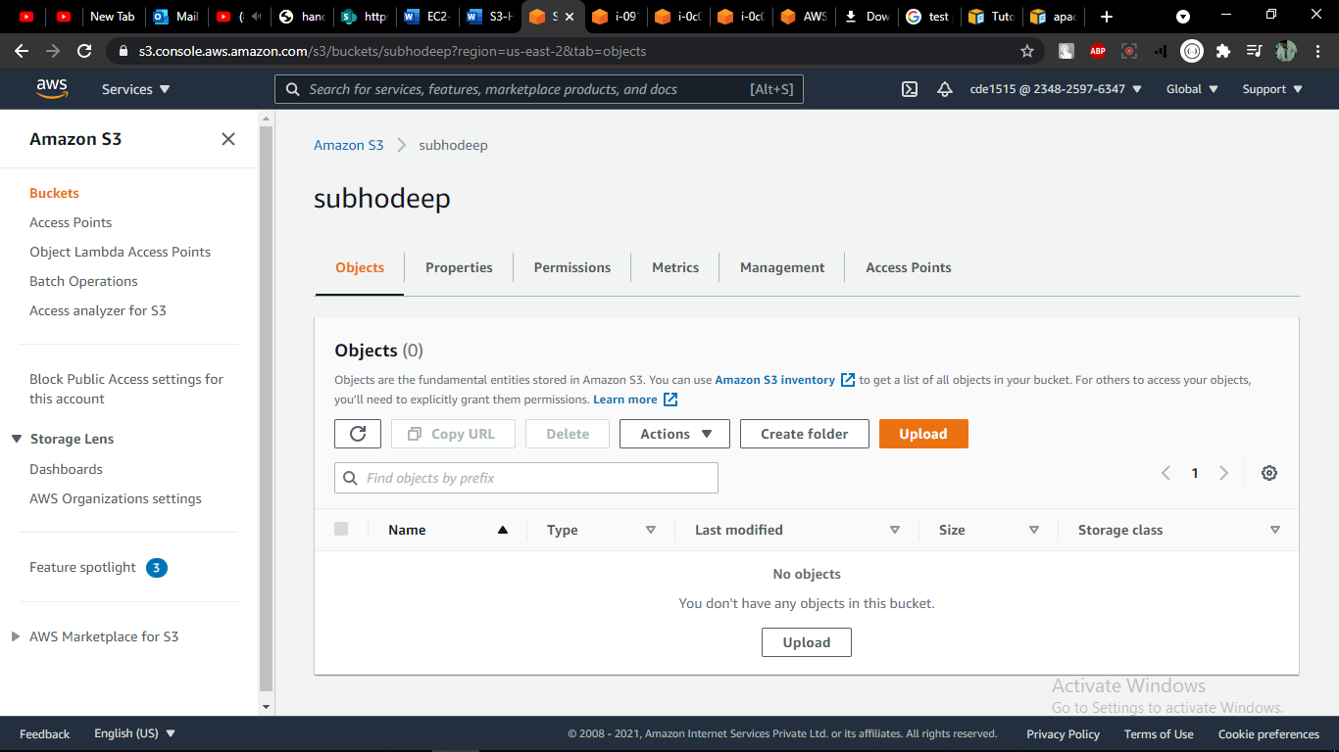

Upload files

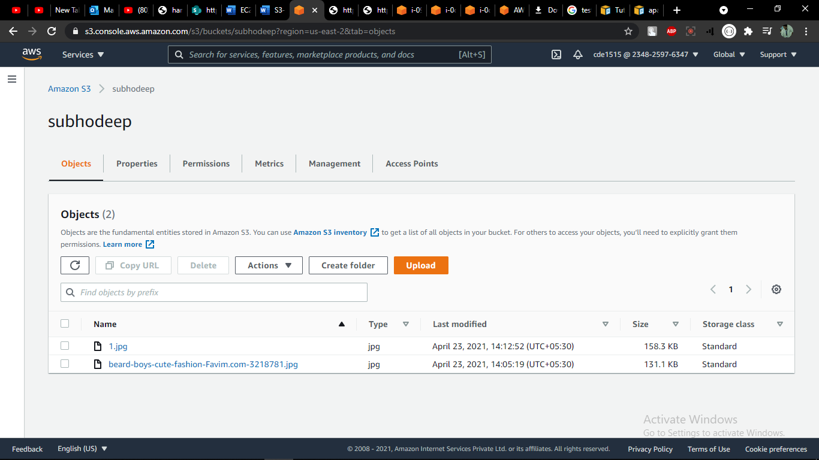

Error because the permissions required to make public

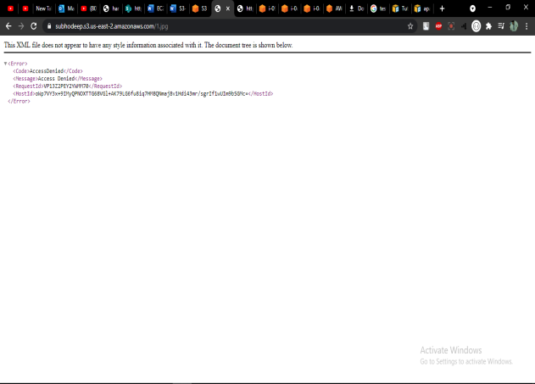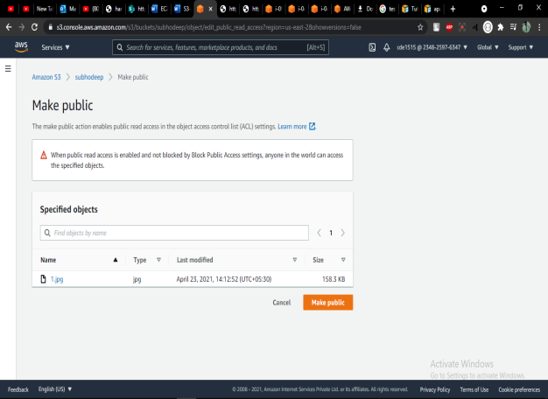

Access the object through URL

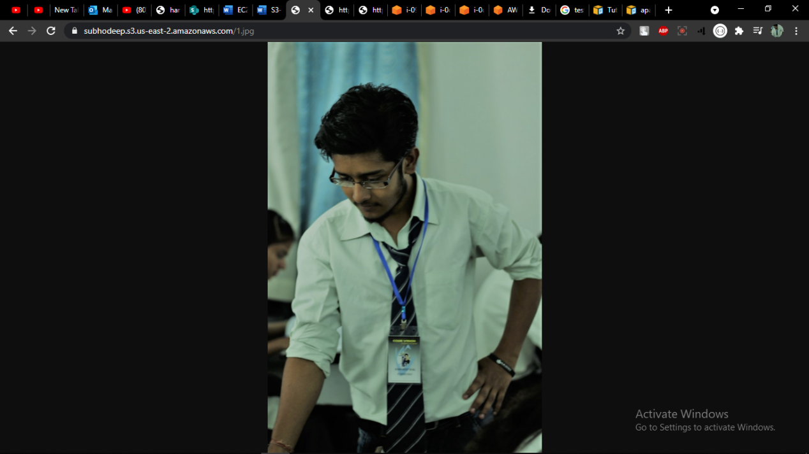

Emptied the bucket

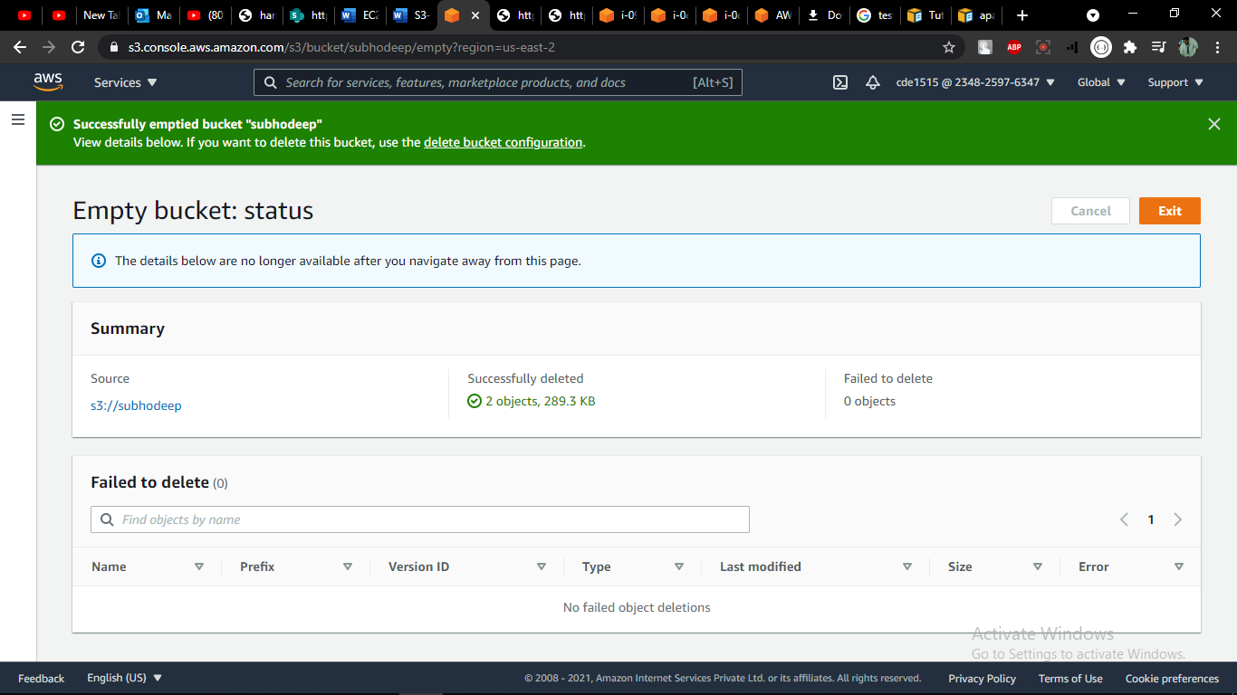

Deleted bucket

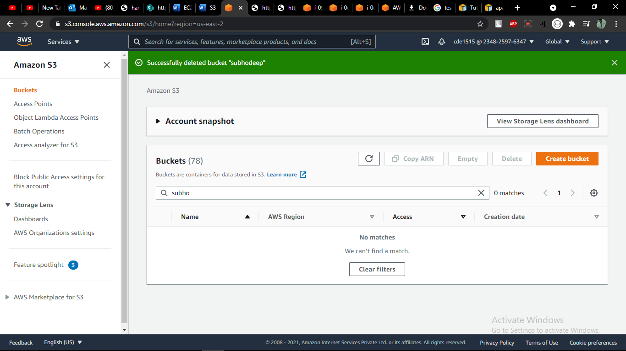

**Day 69**

**RDS Hands-On**

Create a RDS database in AWS and access it through the local client too

Created database instance

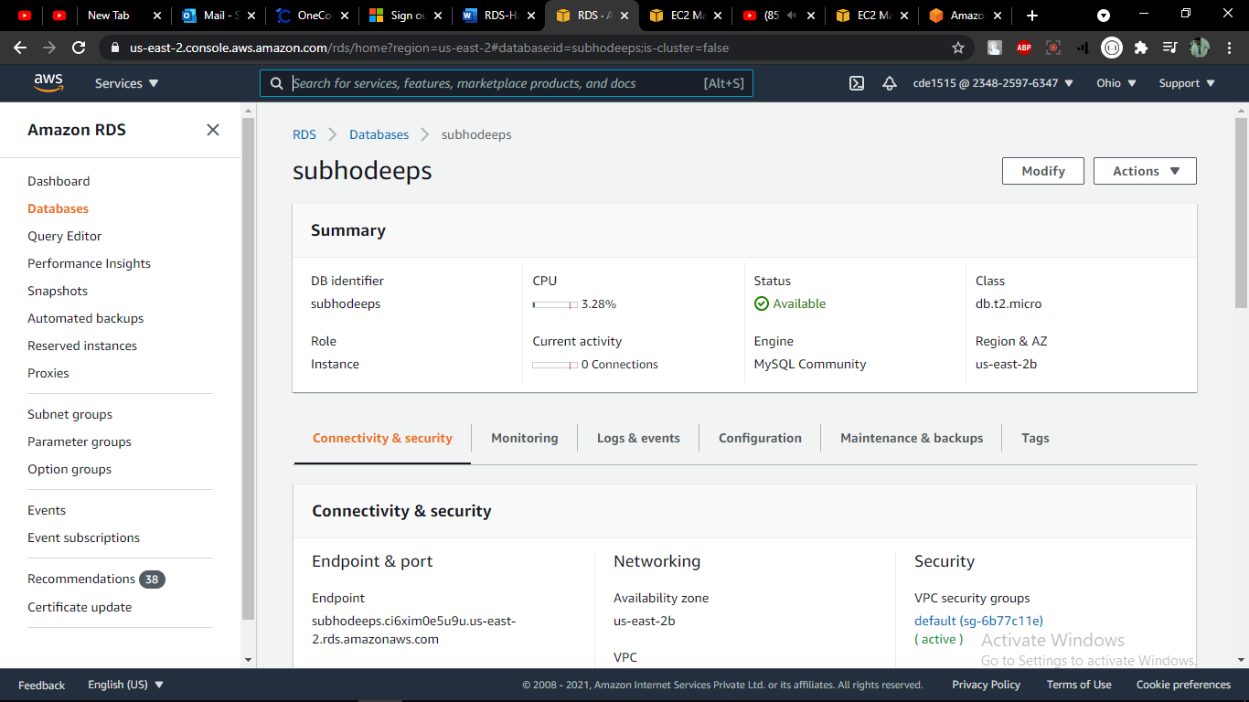

Updated the inbound rules for security group

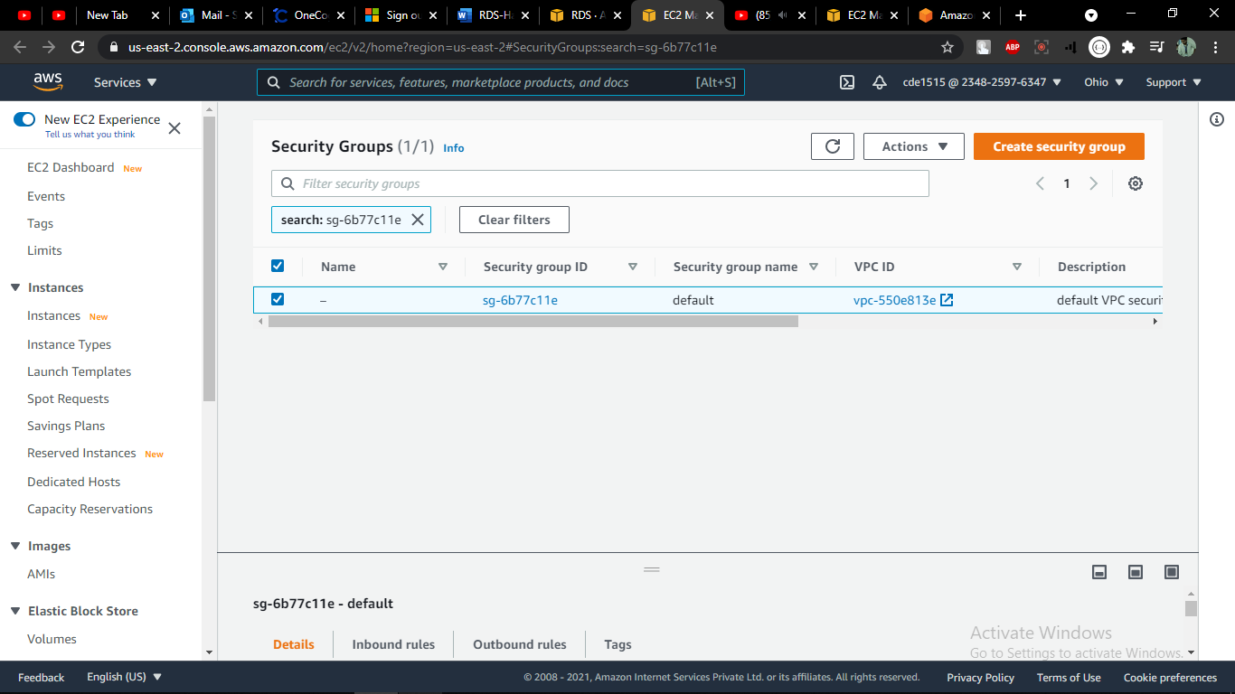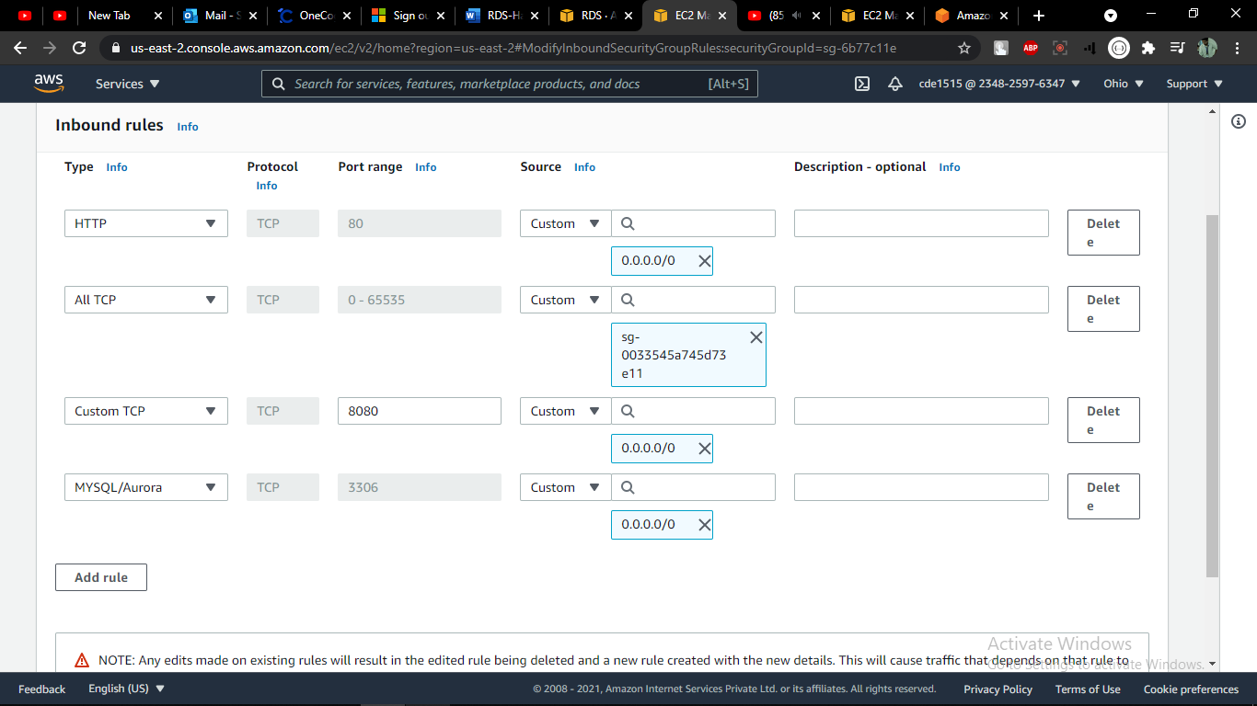

Connecting MySQL with RDS

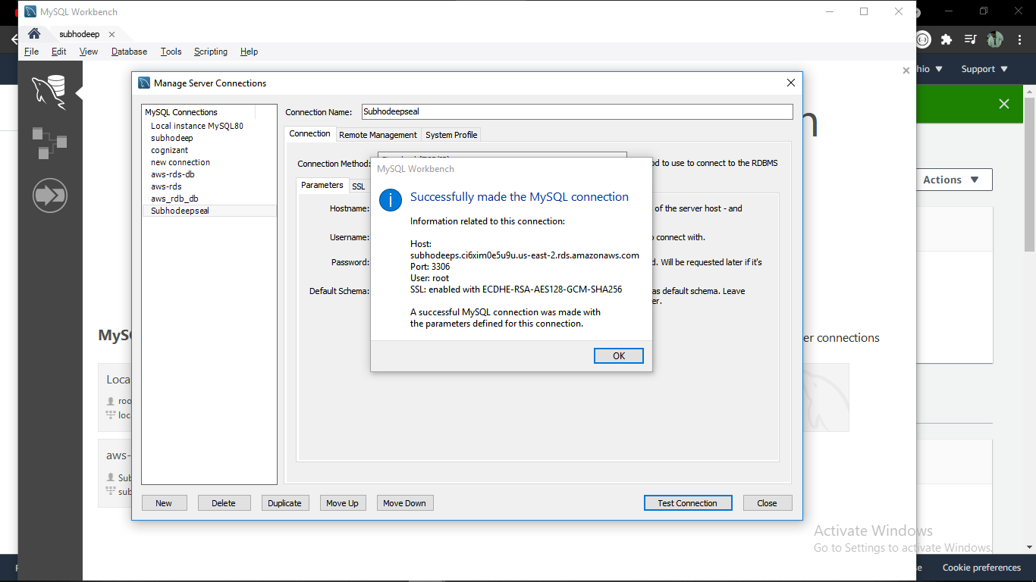

Deleting the instance

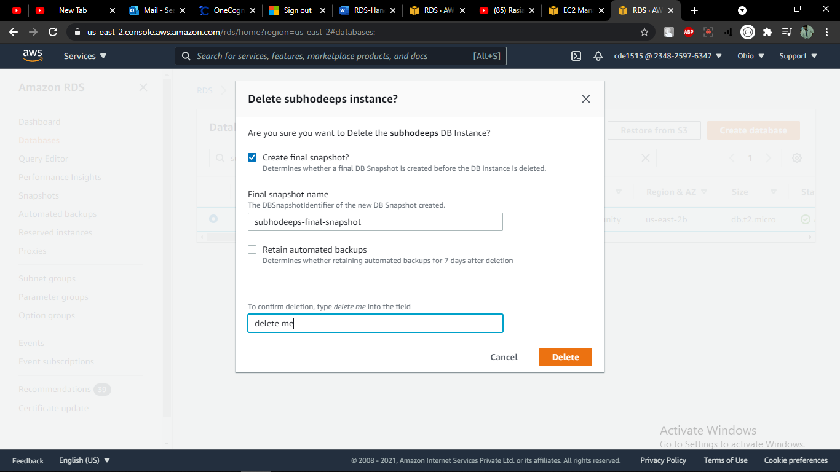

**Day 70**

**Compute: Cloud Fundamentals, Network and Delivery, VPC, Security**

**Groups, Gateway, NACL, Different Services Available in AWS**

Created VPC

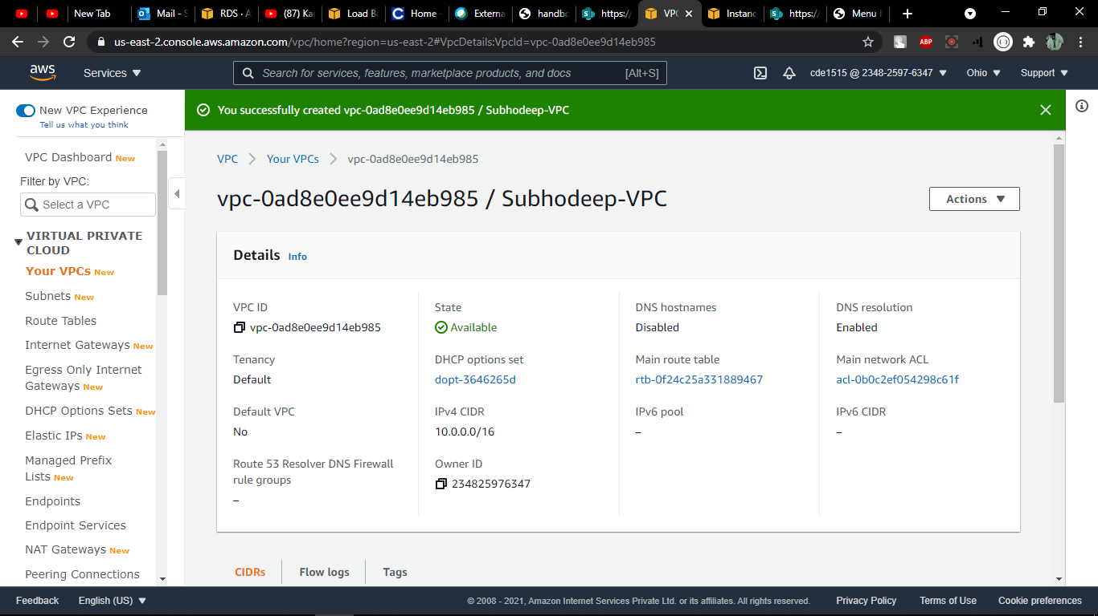

Created Internet Gateway

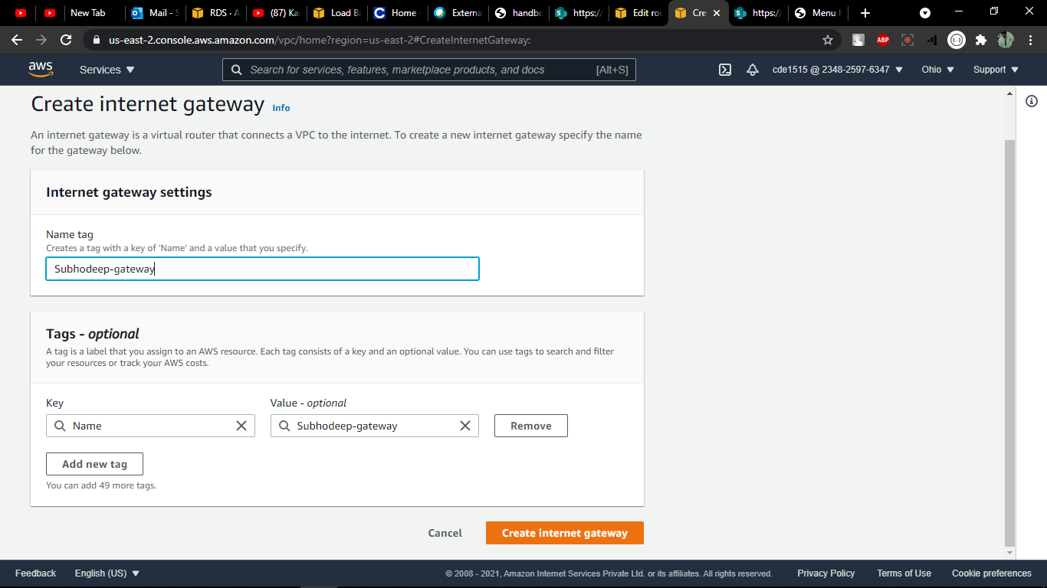

Attached it to VPC

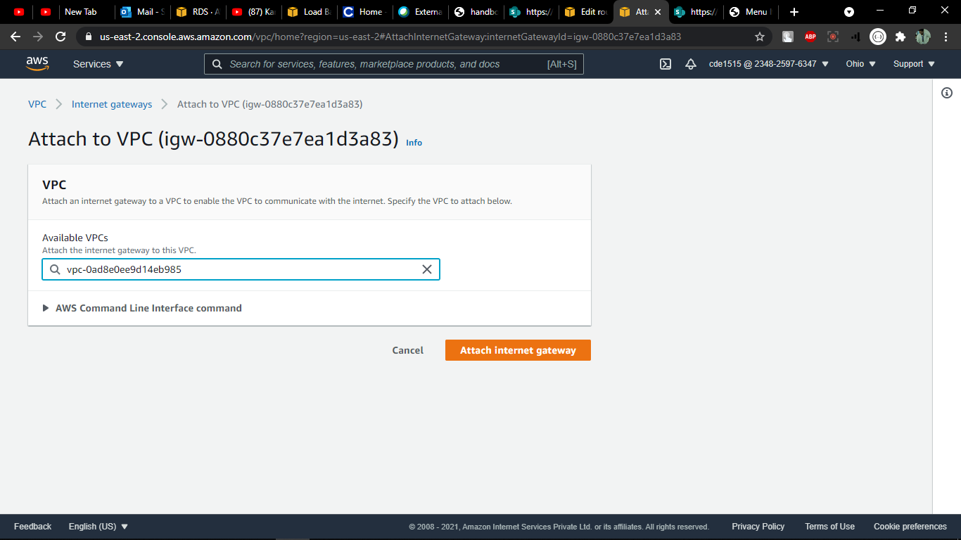

Entered into ACL to edite routes of route table

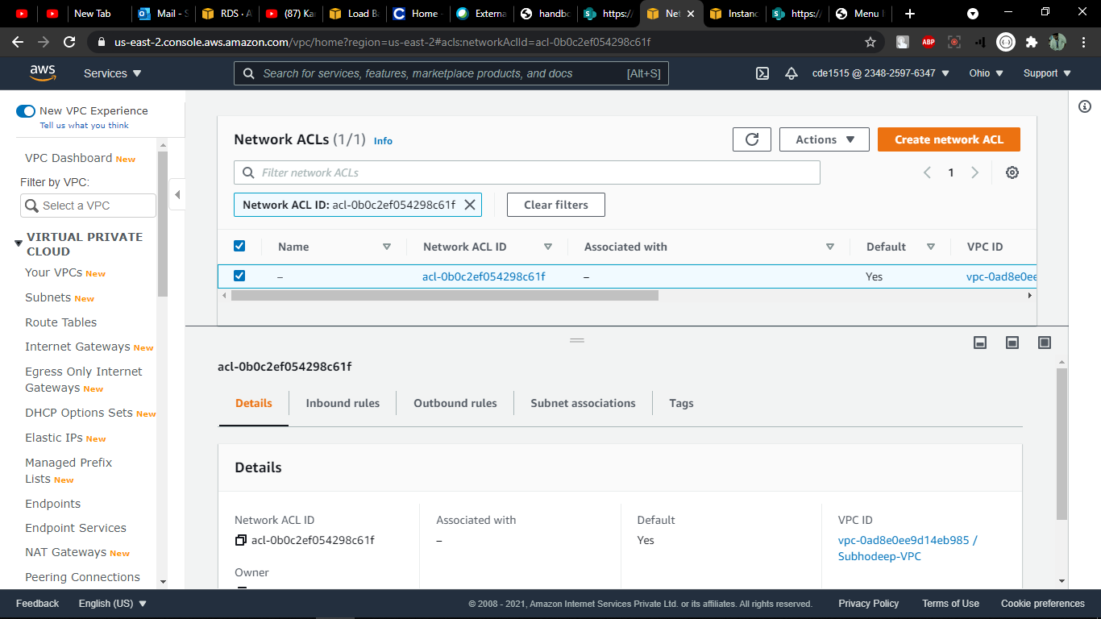

Entered the internet gateway into the route of route table

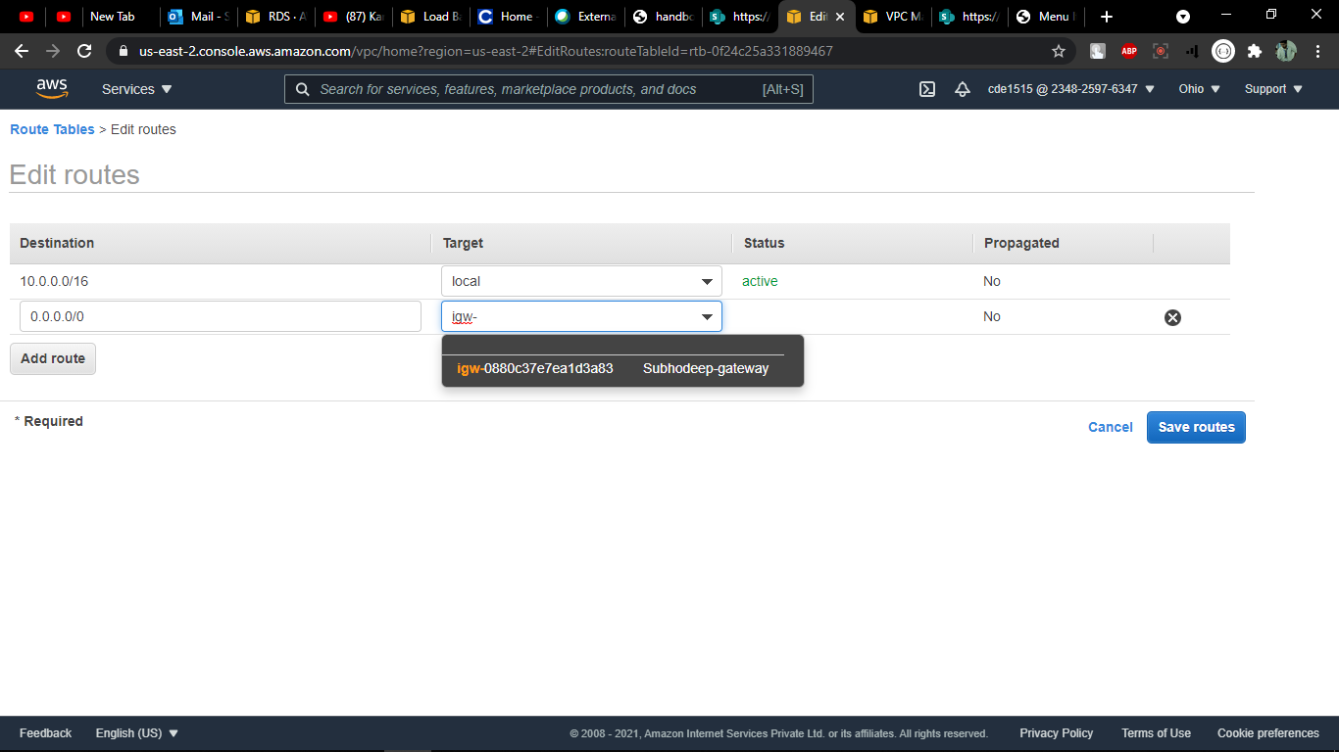

Created subnet

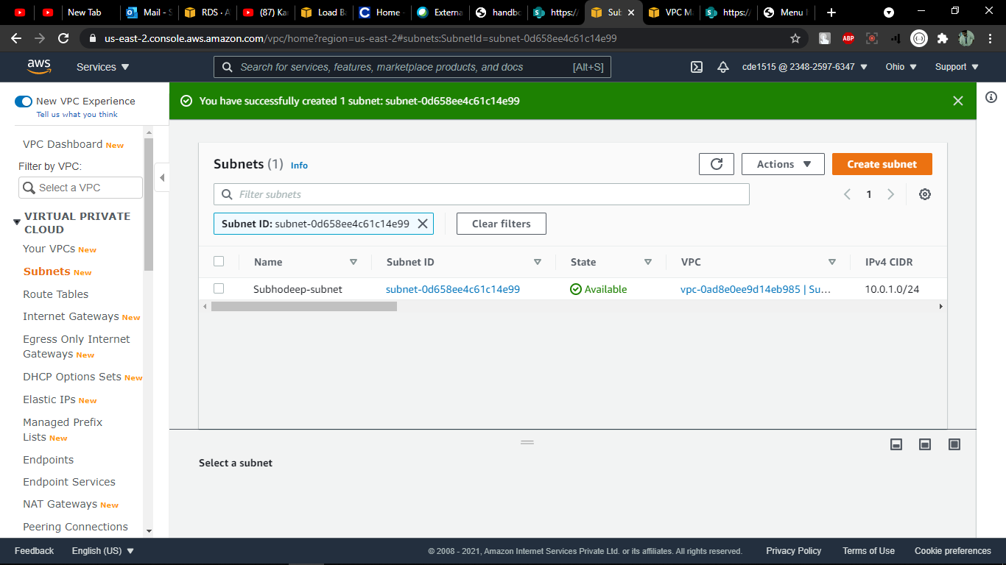

Enetered the subnets into route table

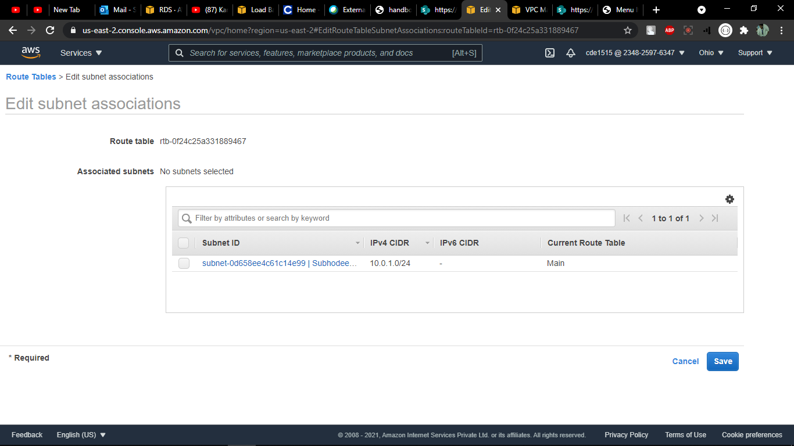

Created security group

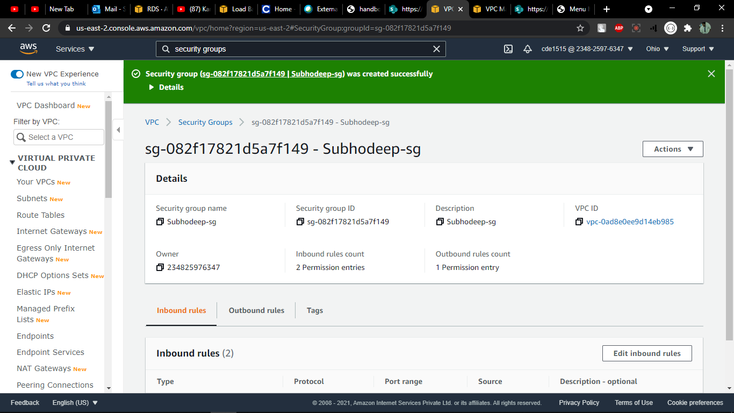

Created an EC2 instance withe those associations of vpc and subnet

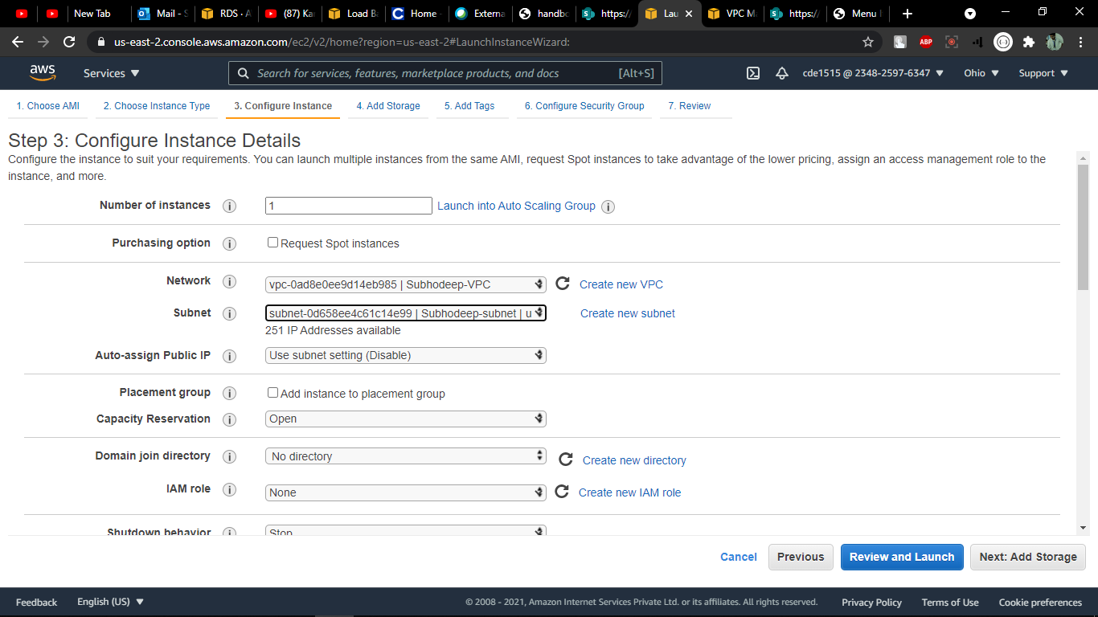

And also configured the security group

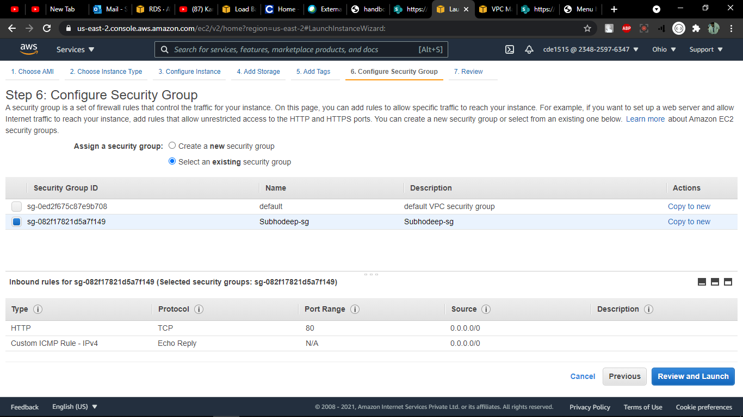

**Day 71**

**Spring-REST-with-RDS-Backend**

Create a Spring REST application that perform Read and Insert operation on RDS database. Deploy the application in AWS Elastic Beanstalk and access the application from anywhere.

Created RDS Database

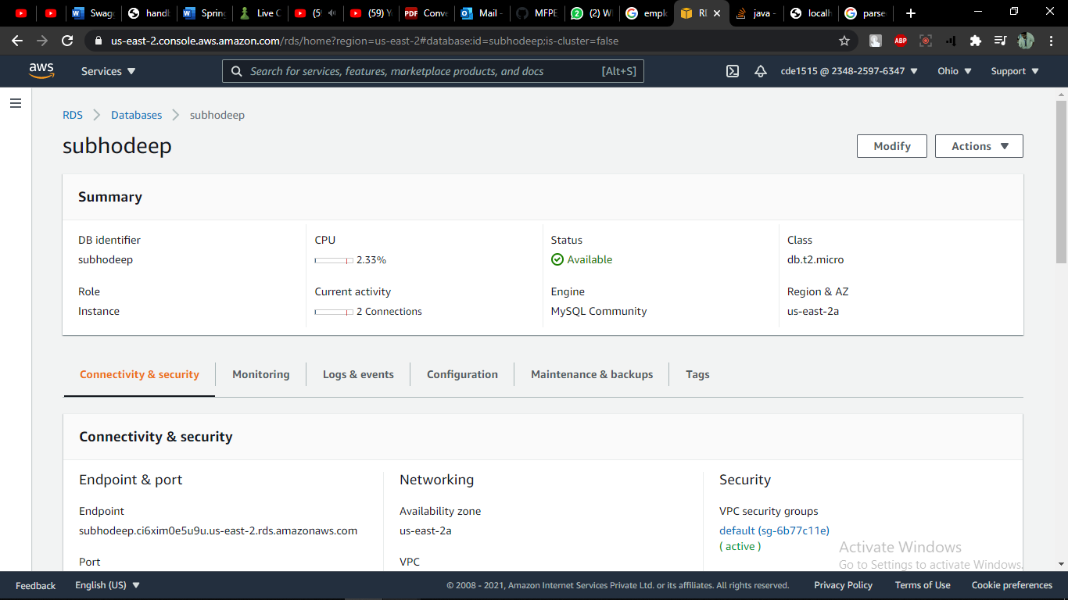

Connecting RDS to MySQL

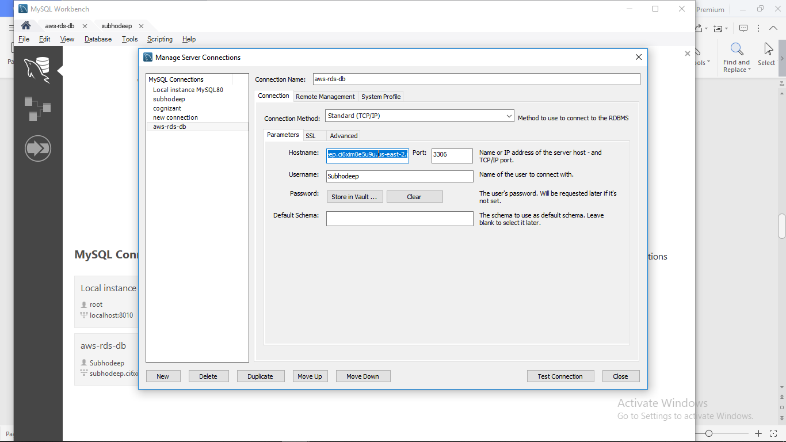

Creating database

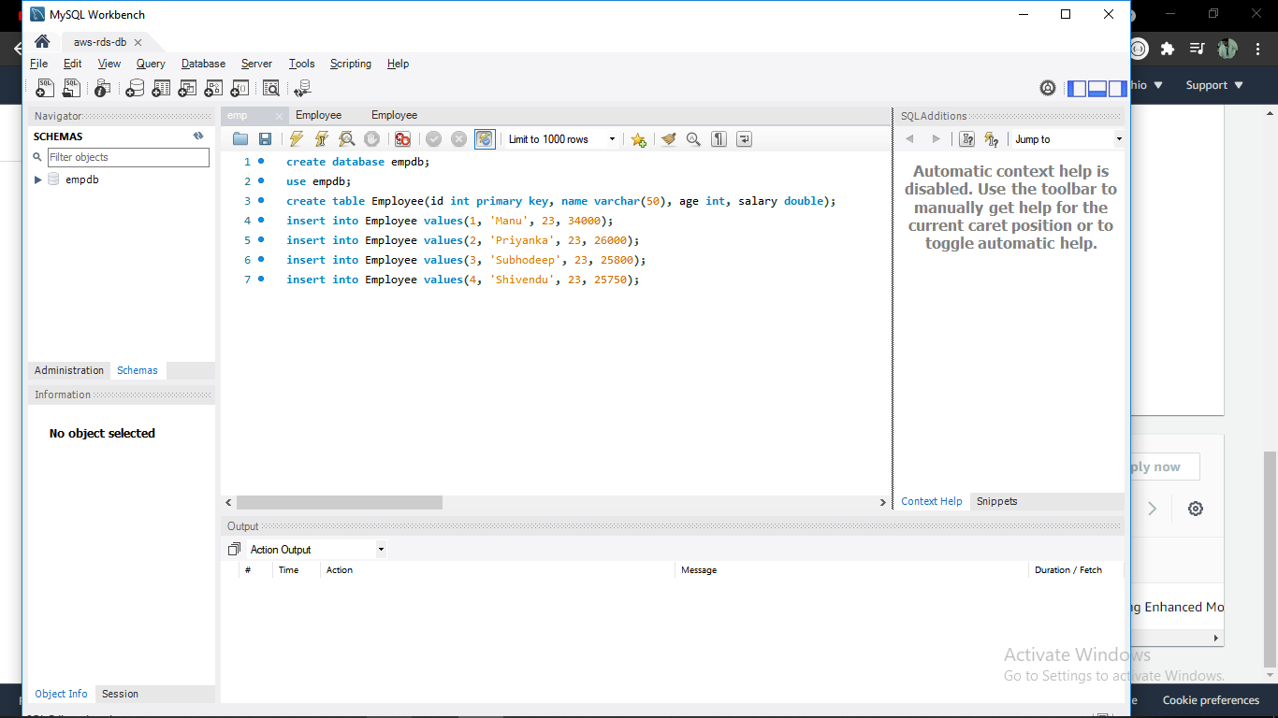

Created environment for Elastic Beanstalk

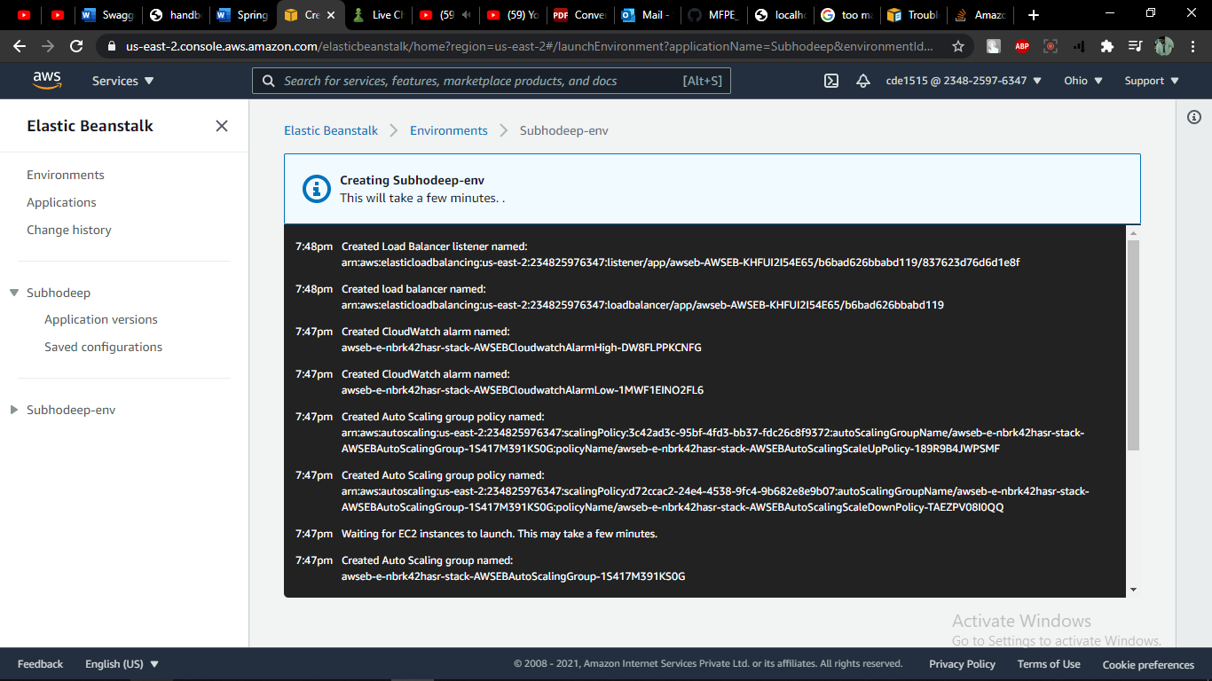

Started Elastic Beanstalk instance

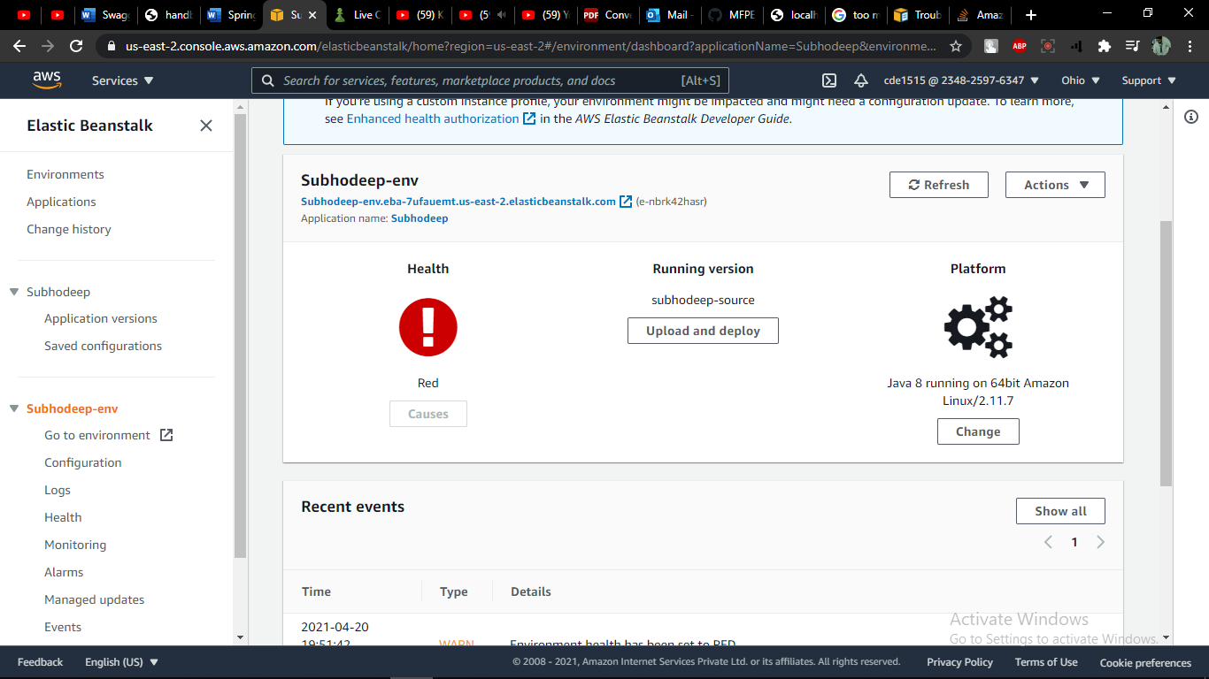

Make the rest api code build into snapshot jar

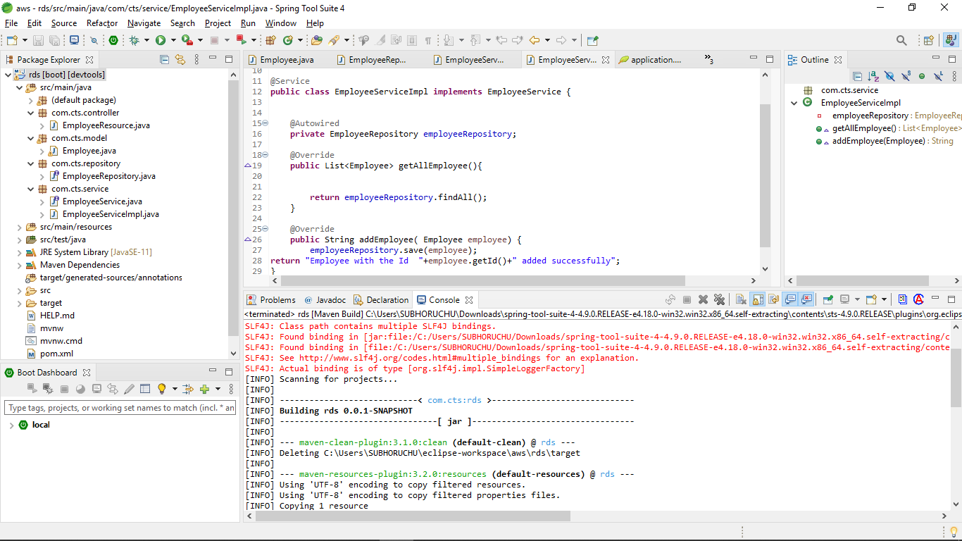

Opened the aws URL given in the dashboard of the elastic beanstalk ec2 instance

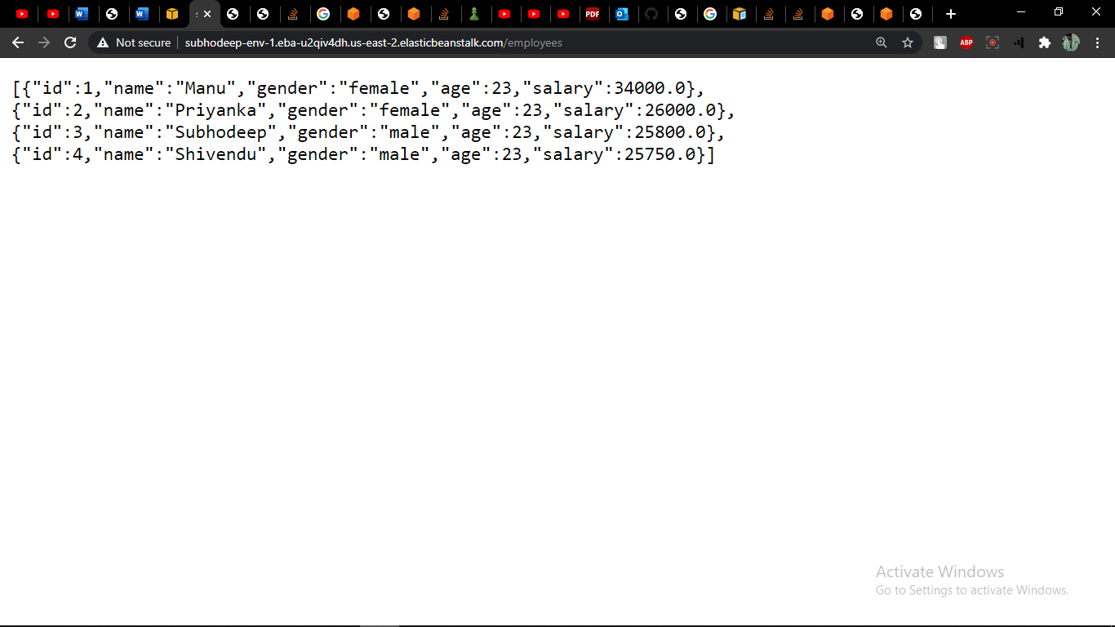

Tested the aws URL in Postman

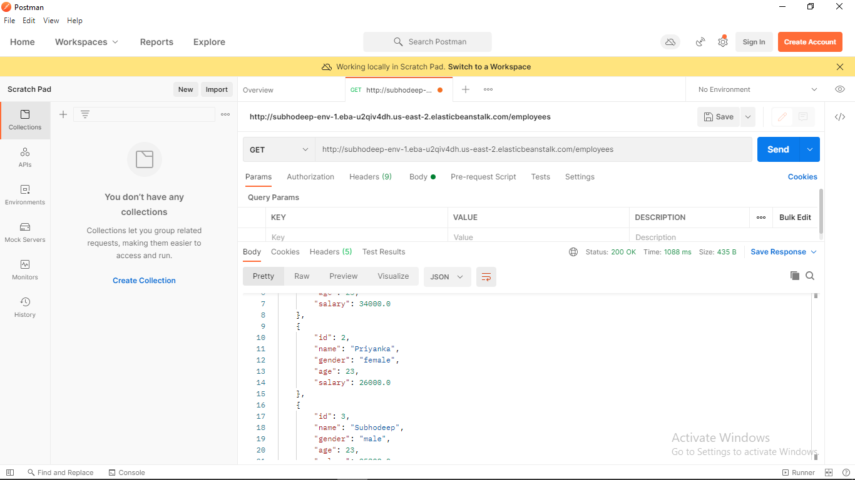

**Day 72**

**Swagger-Hands-on**

Make use of Swagger to create documentation for RESTful/microservices

Swagger implied in Model class of the code

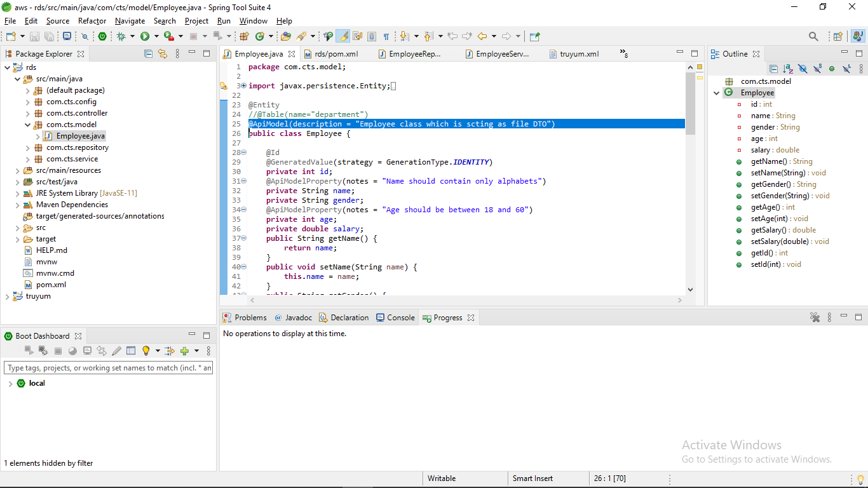

Swagger docs

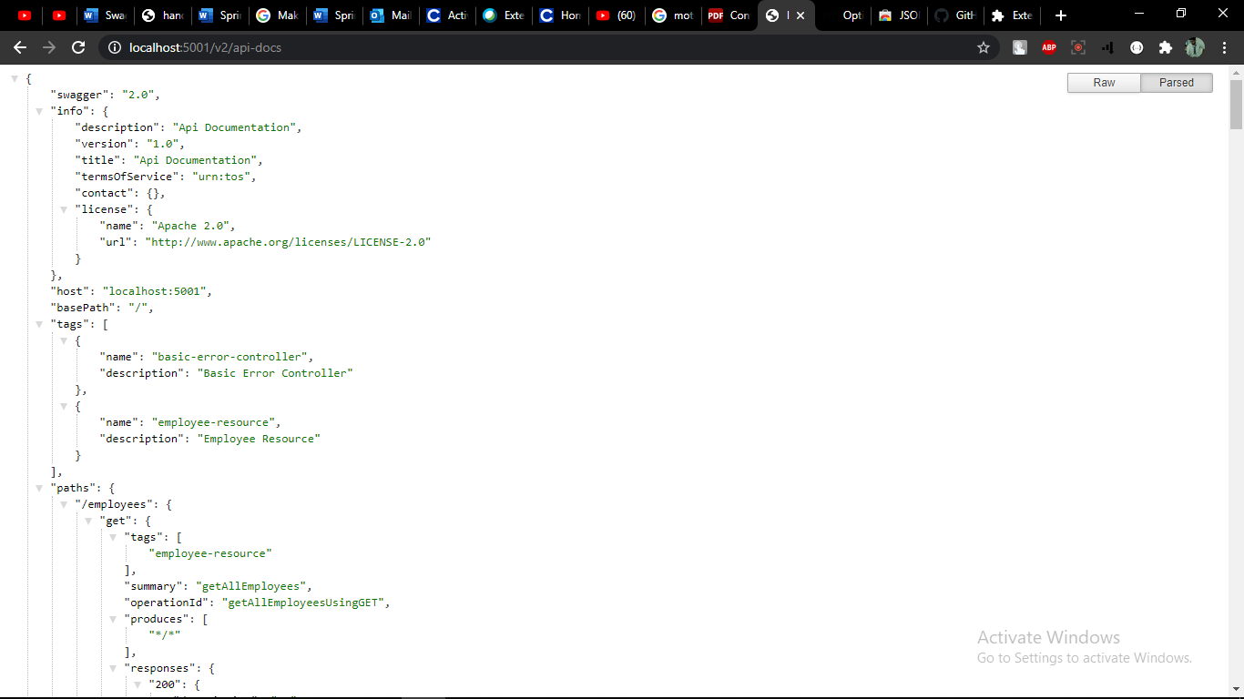

Implementation seen in description

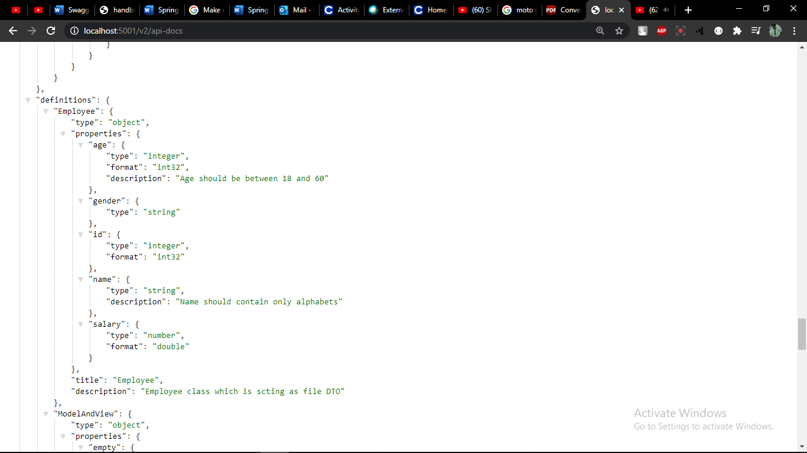

**Day 73**

**Spring MVC Client for Spring REST Service**

Create a client application using Spring MVC and Spring Boot and consume the REST service

Connecting two microservices employee spring and employee mvc using the URL of one into another

In employee mvc, application properties :- feign.url-employee-spring = localhost:8080/emp-spring/employees

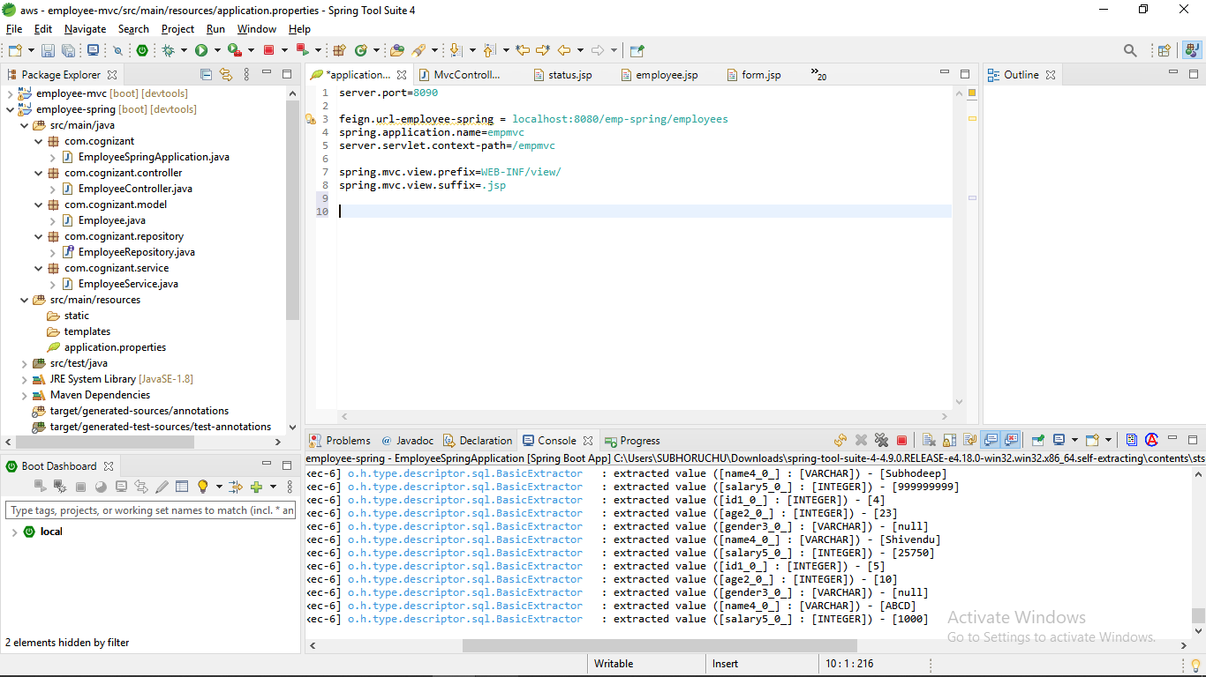

Update using Postman

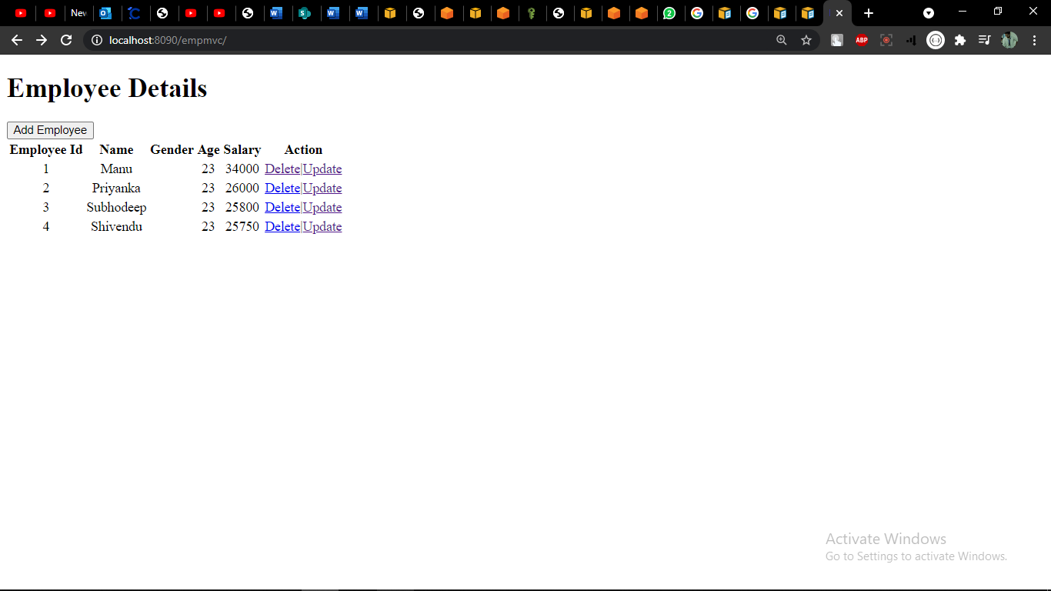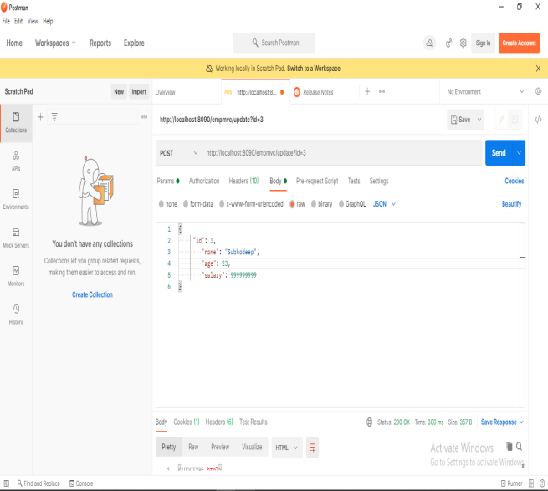

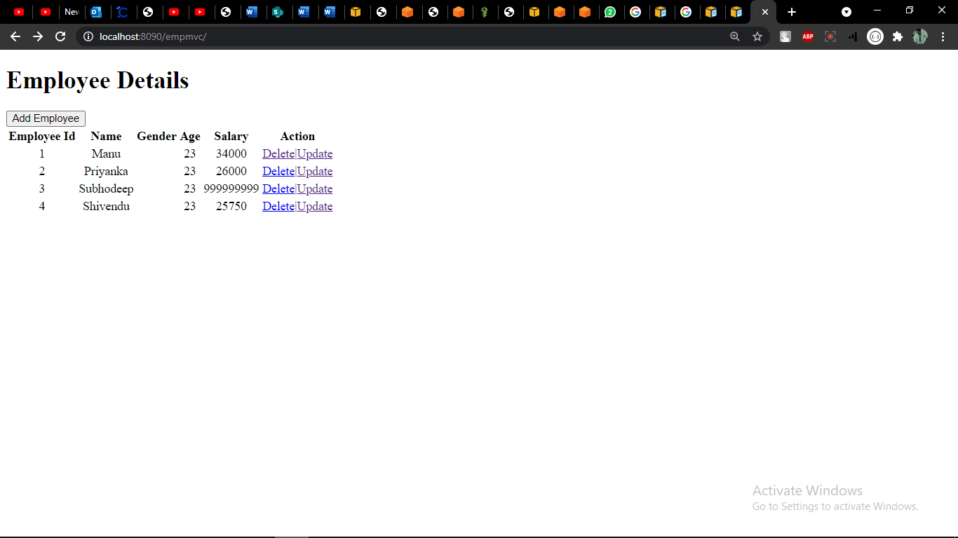

Delete using form

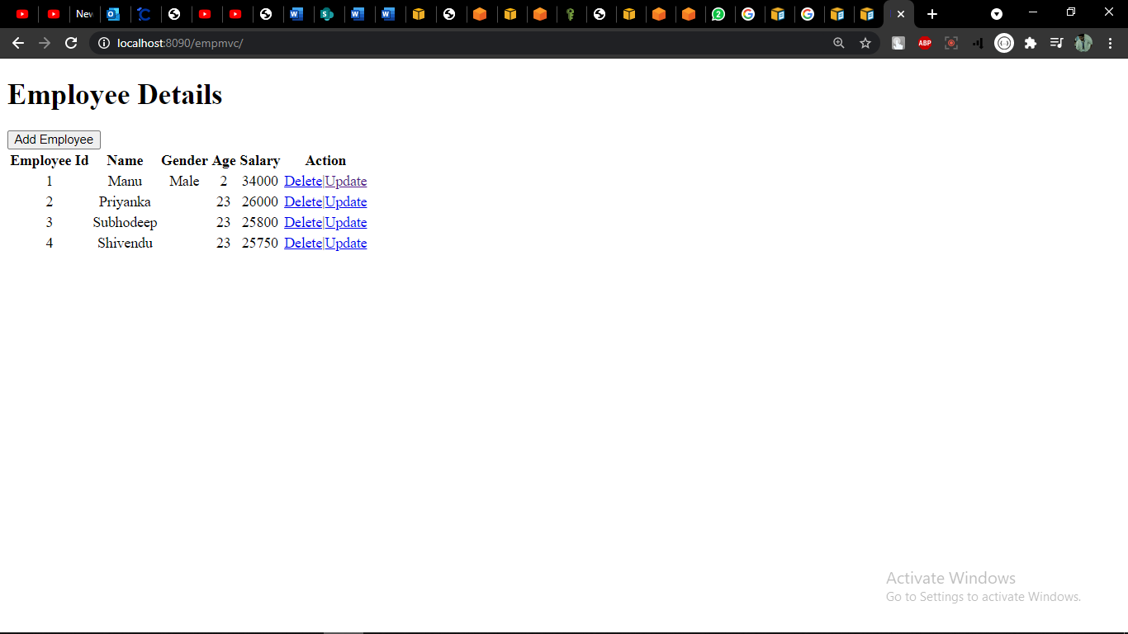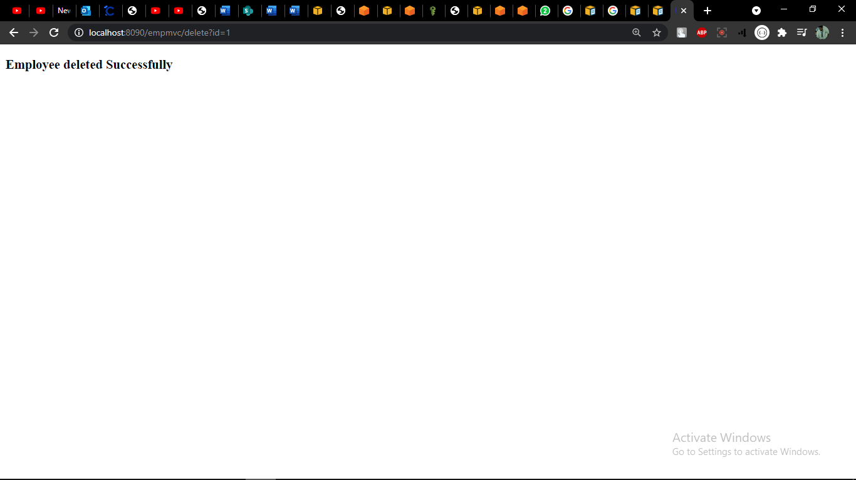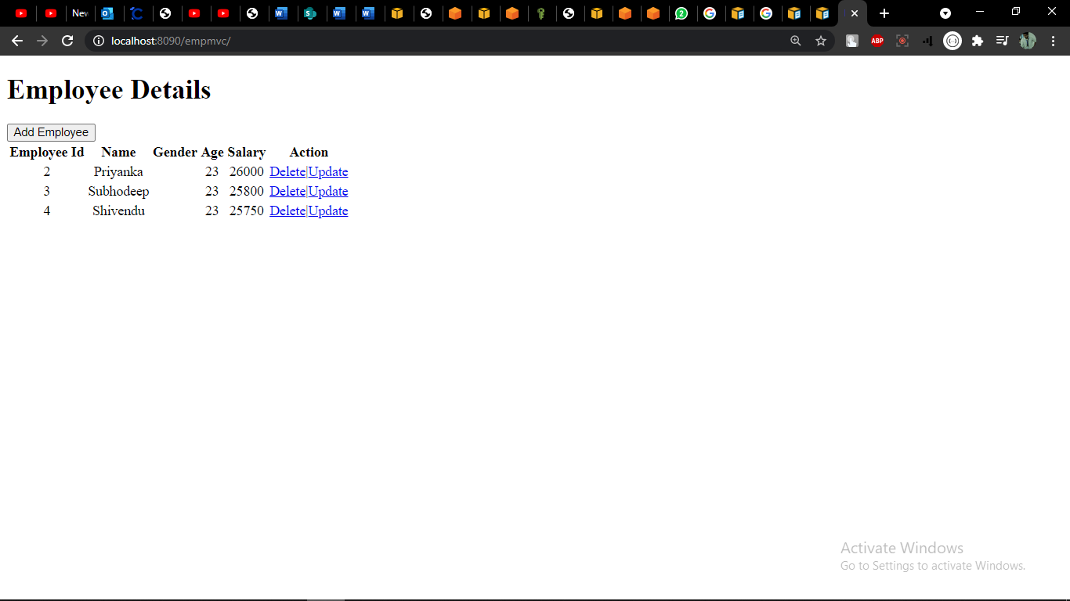

Added using form

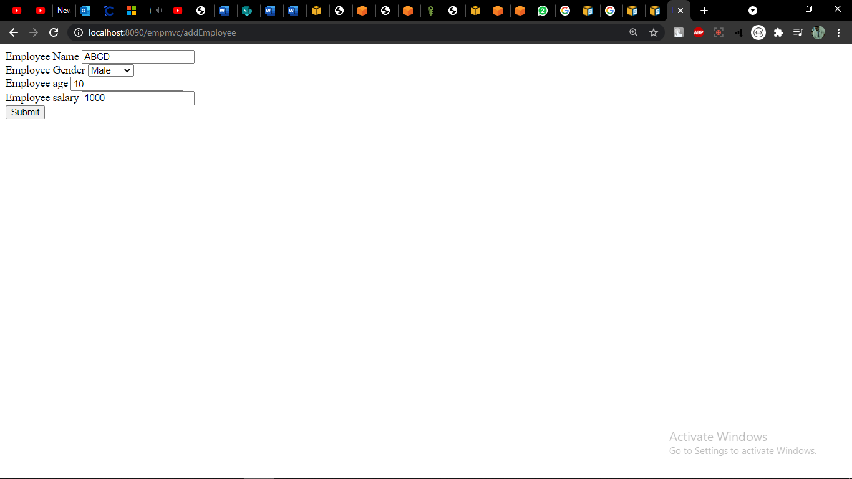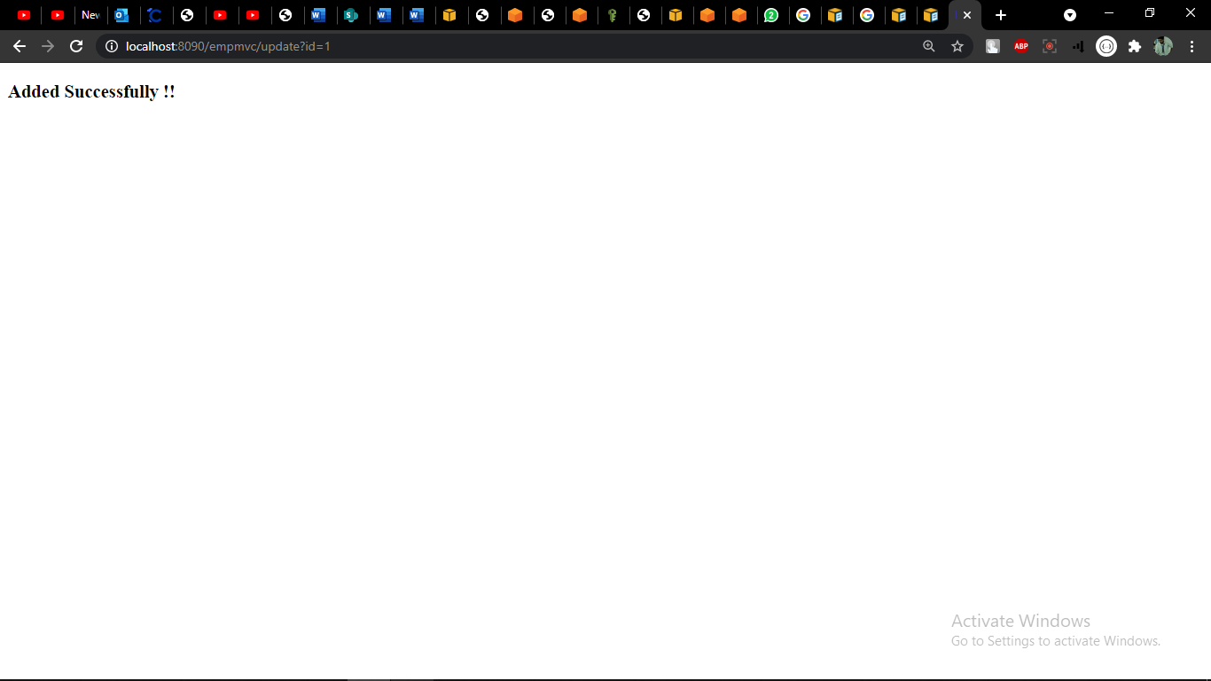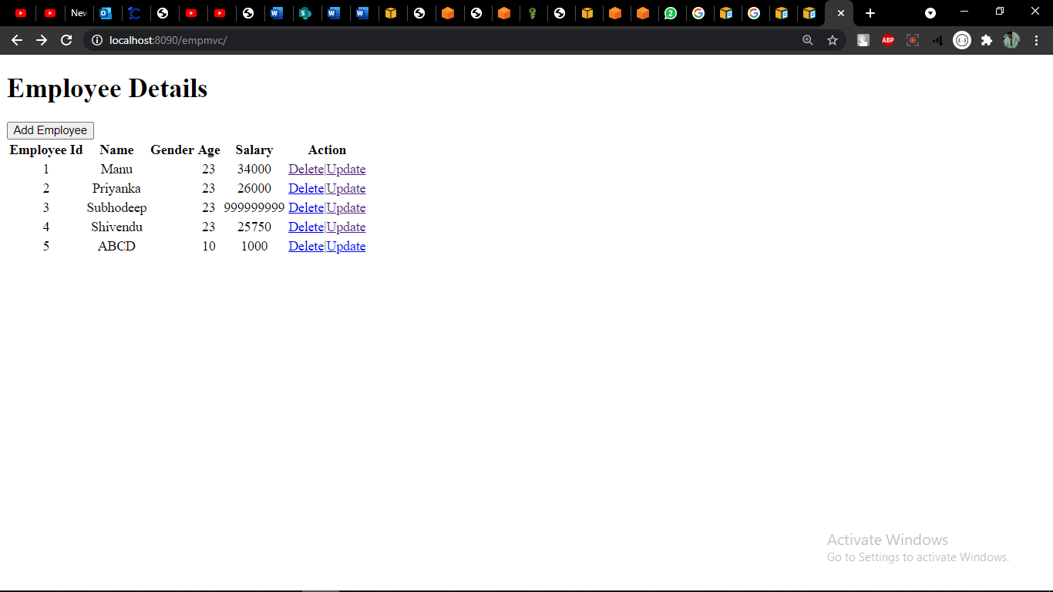

**Day 74, 75**

**PRACTICE CHECK**

**AWS RDS, ECS, ECR, ALB, Fargate Deployment, CI/CD**

AWS RDS, ECS, ECR, ALB, Fargate Deployment, CI/CD

Code Commit - Created a repository

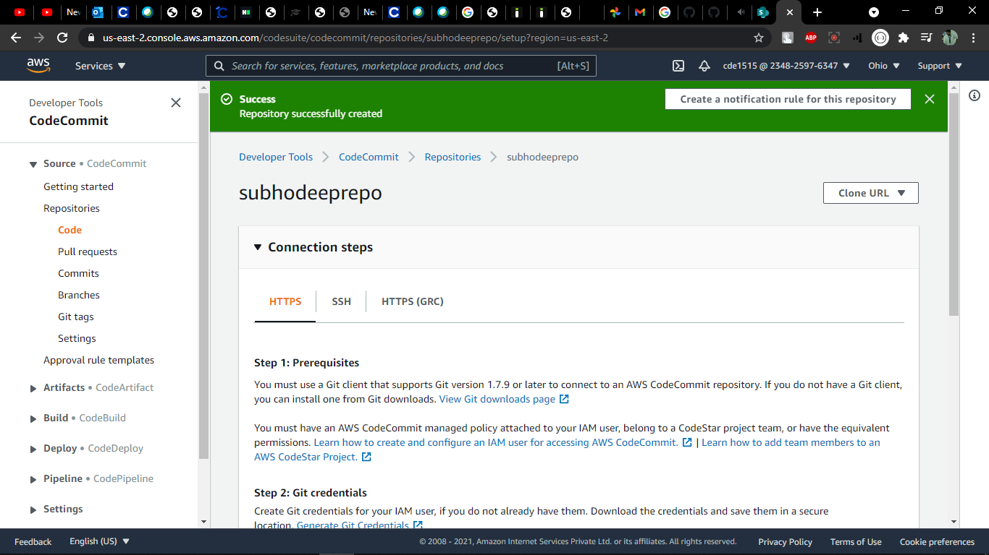

Created an IAM user and downloaded the access id and password

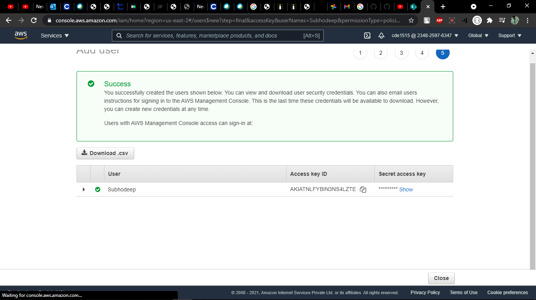

Pushed the code in the repository

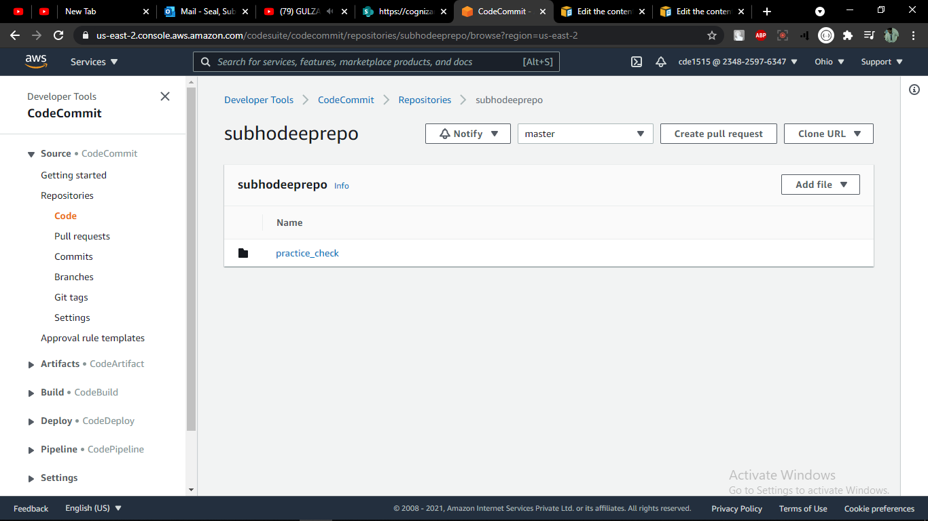

Created the service registry repository

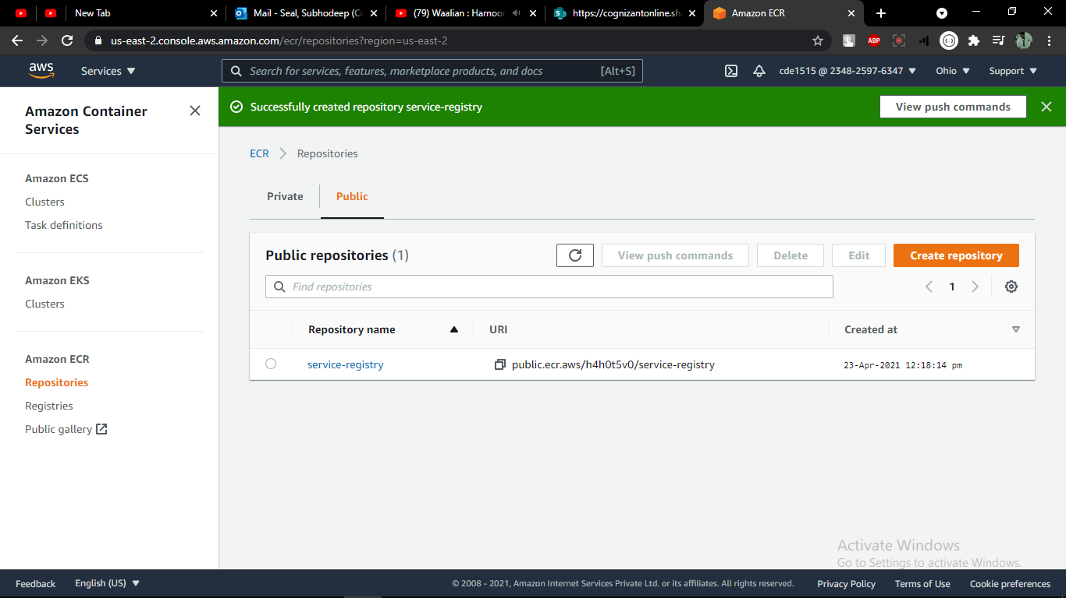

Created an ECS cluster

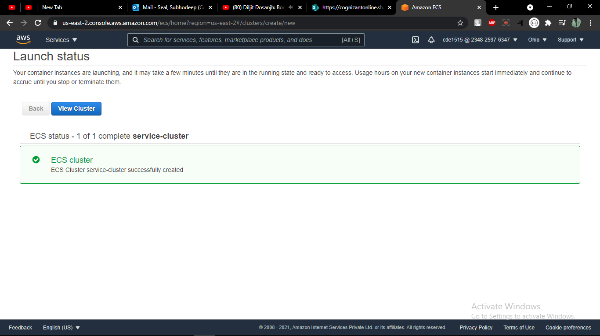

Created Task-Definiton

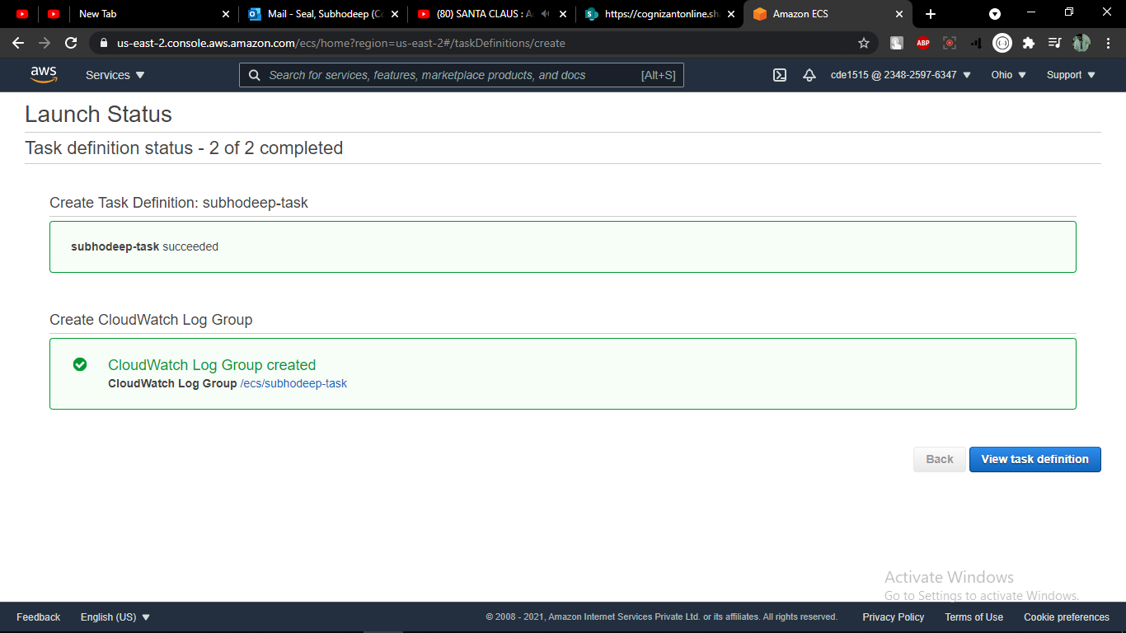

Created Load Balancer

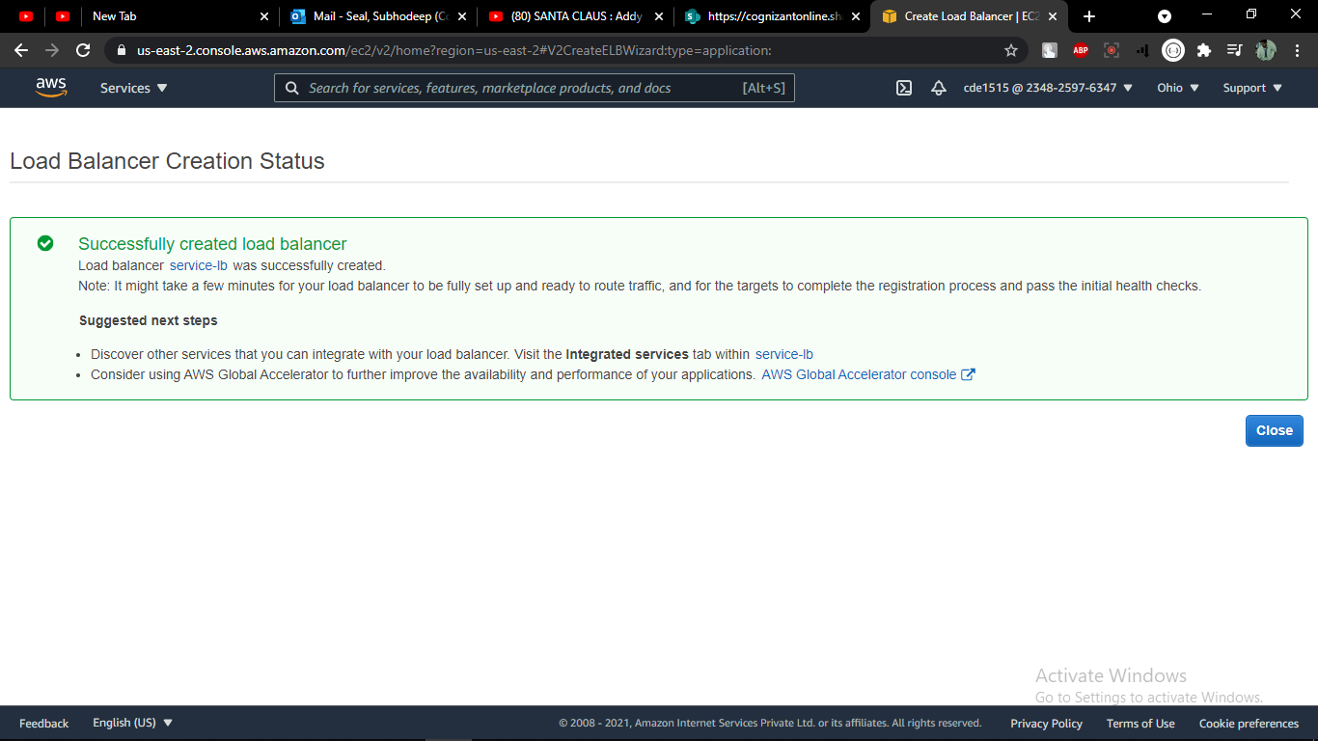

Entered the service cluster to update inbound rules for security groups

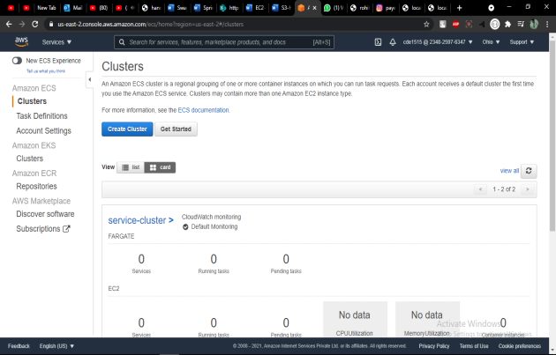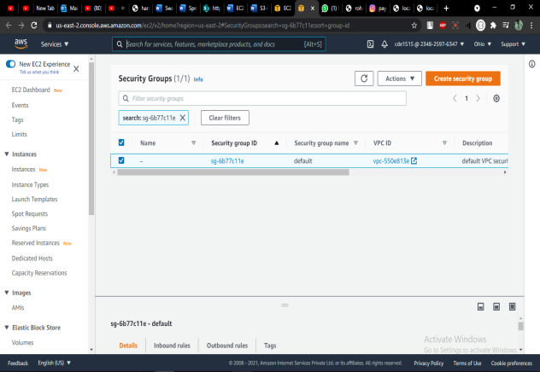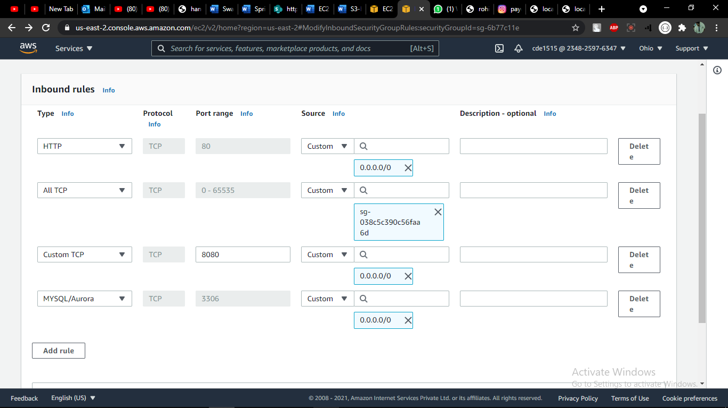

Created service

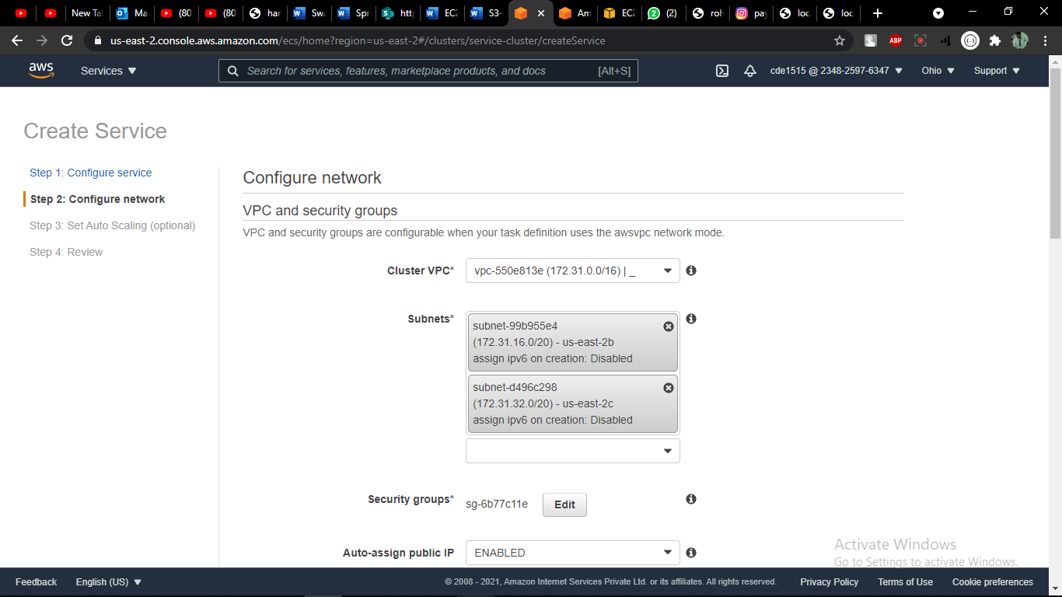

Entered Auto-Scaling properties in load balancer

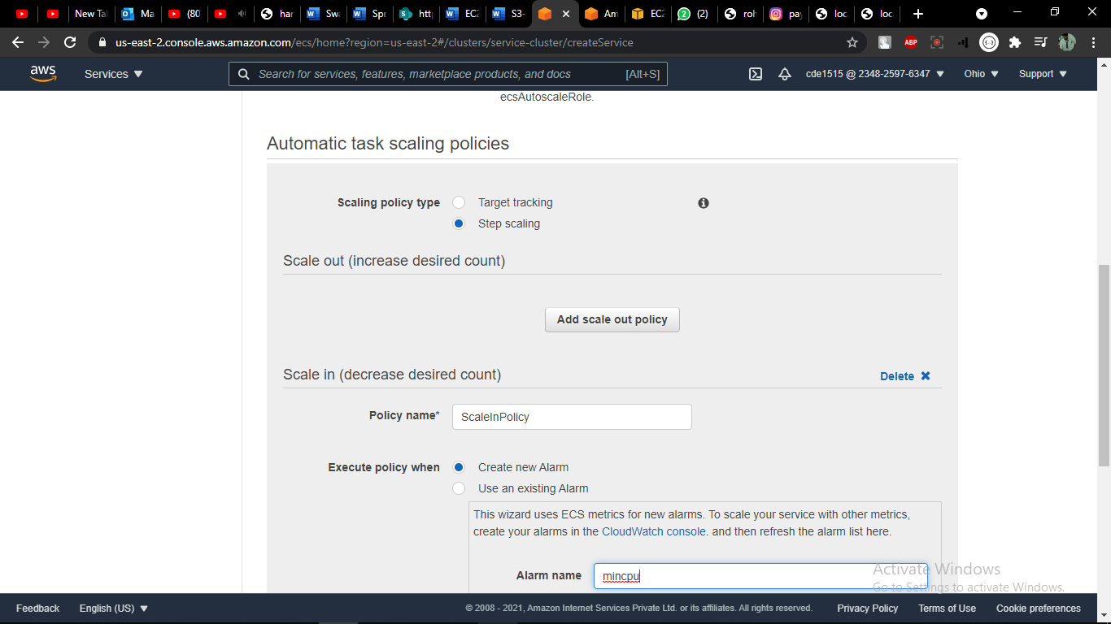

Service creation completed

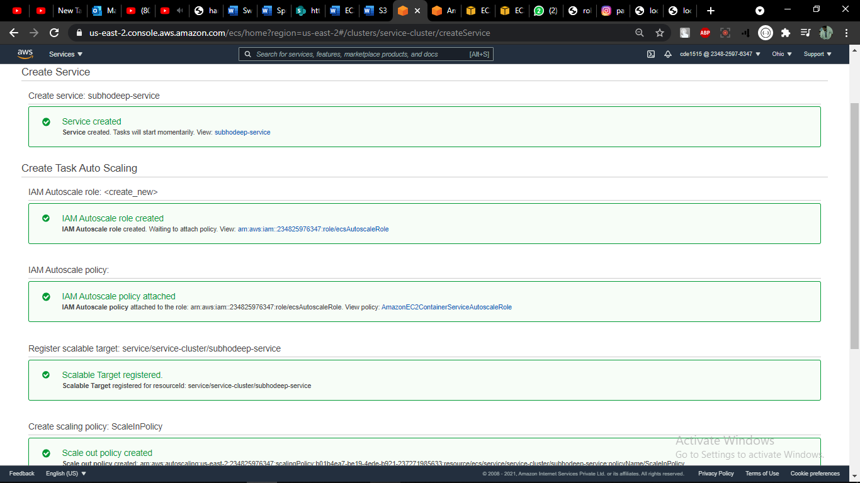

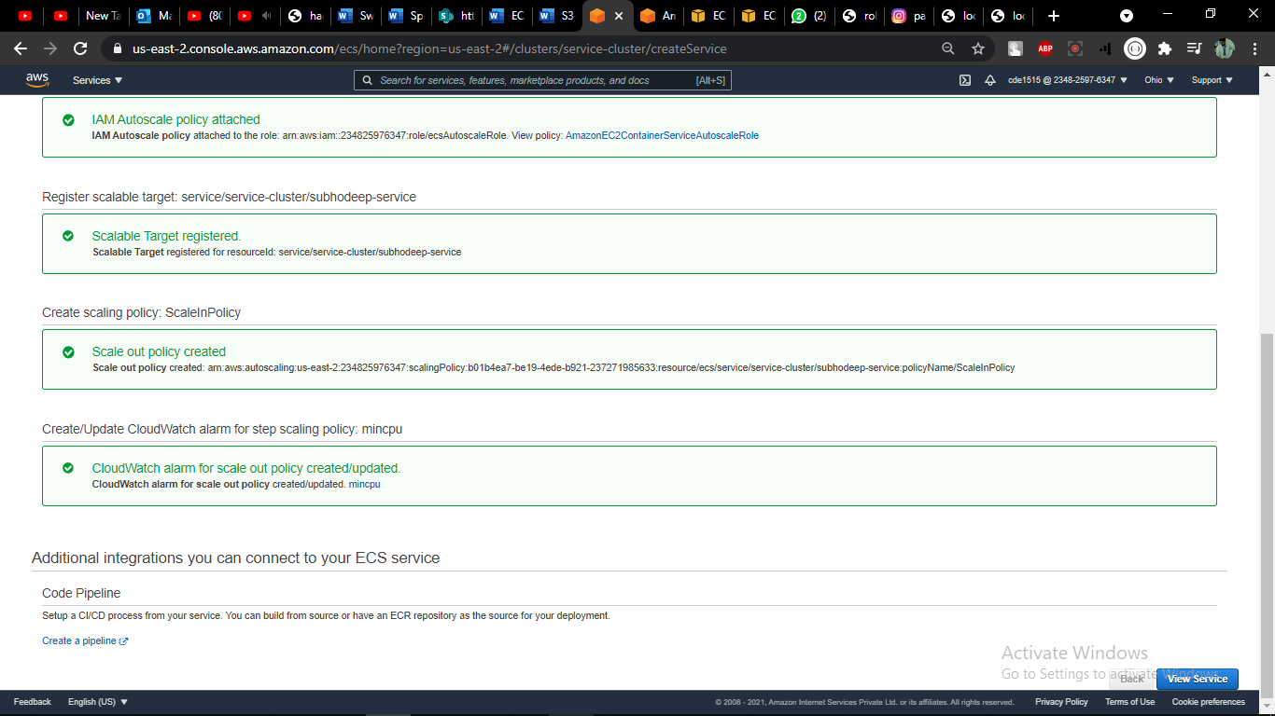

Created PIPELINE

**Source**

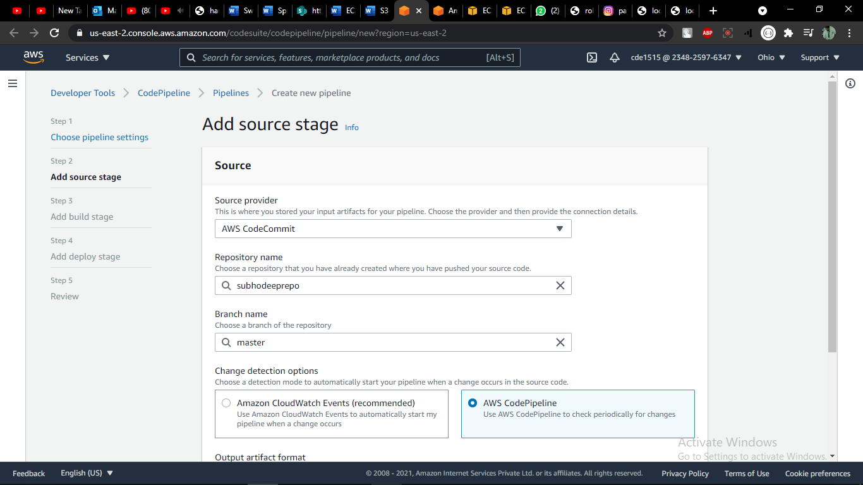

**Build**

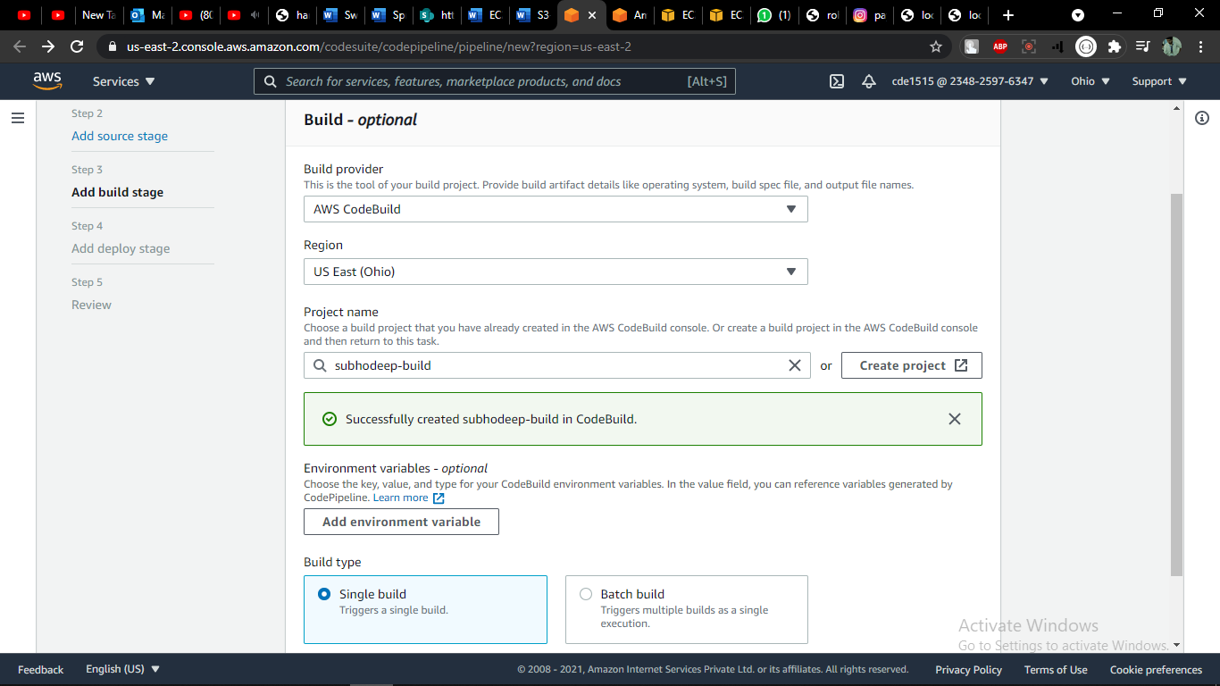

**Deploy**

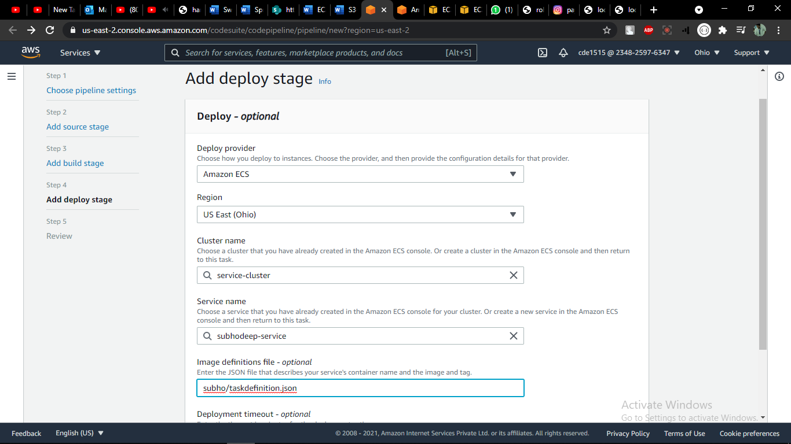

Grant permissions in IAM for the Registry

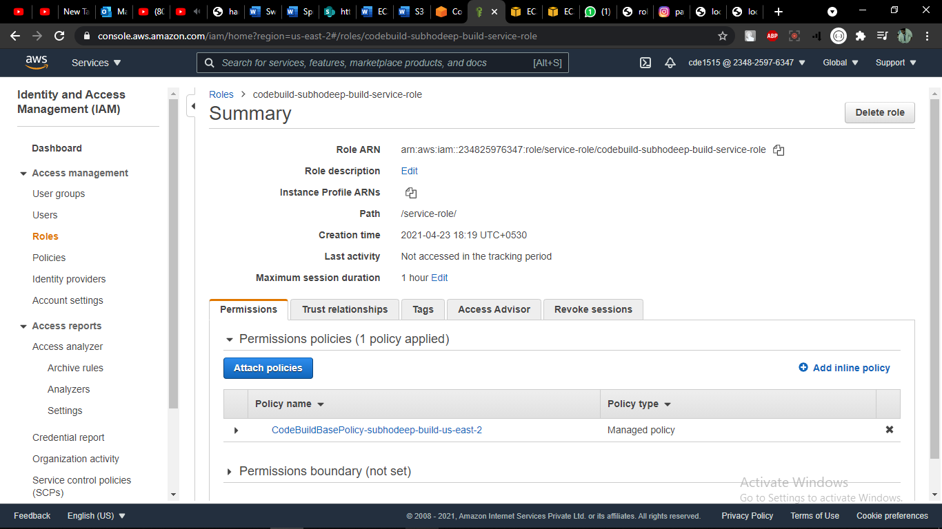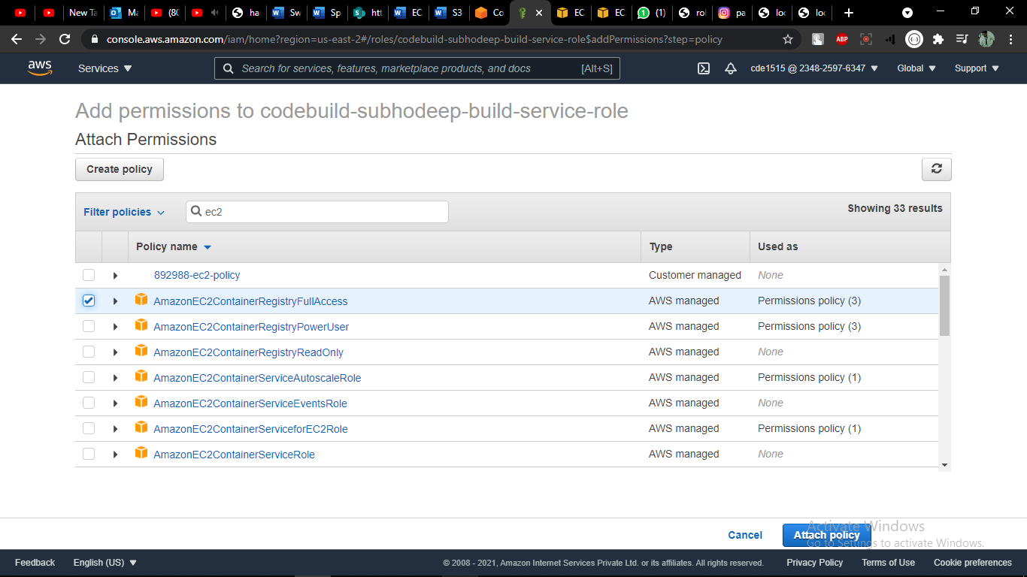

**Going through PIPELINE**

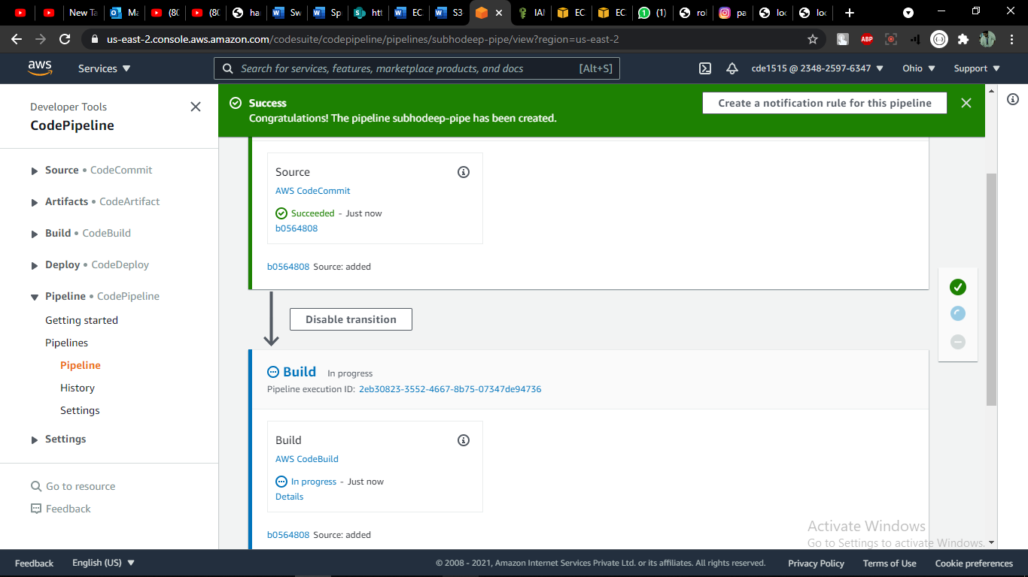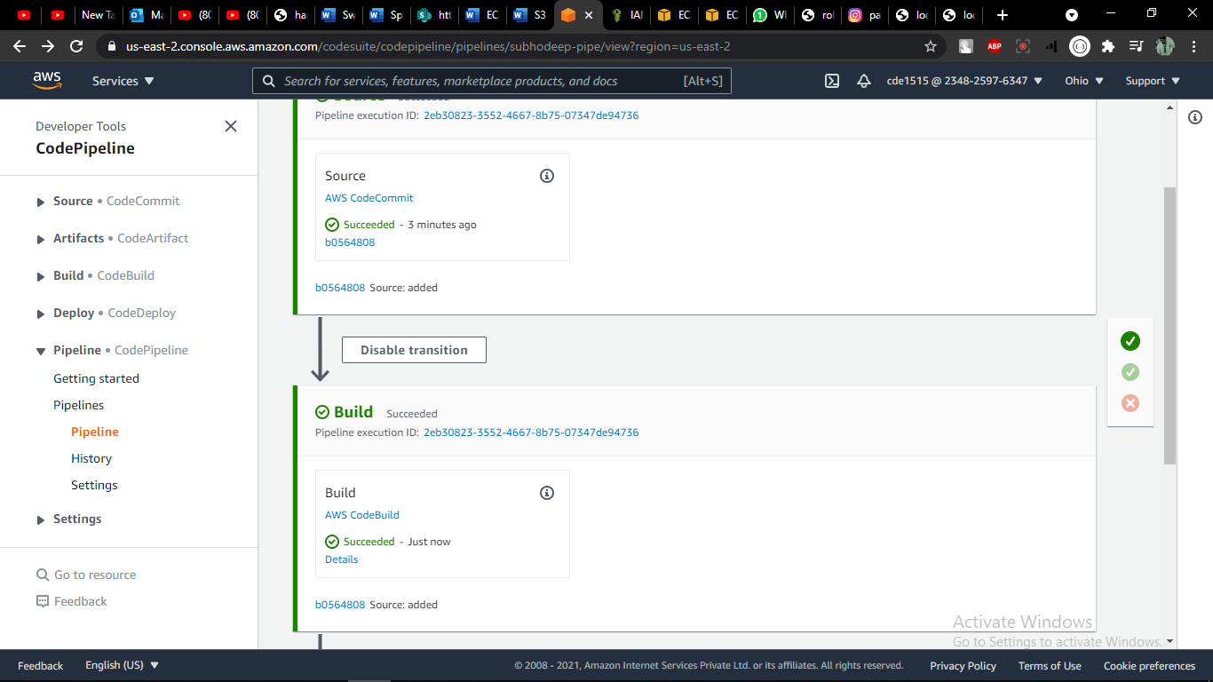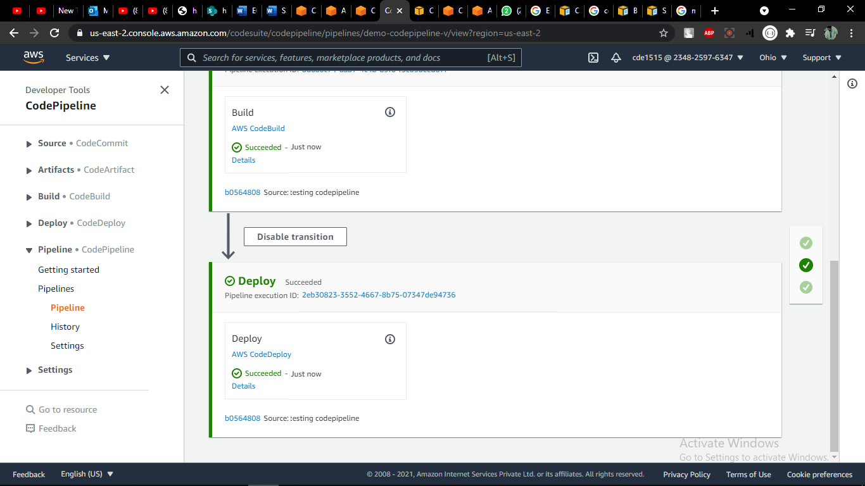

Copied the aws url

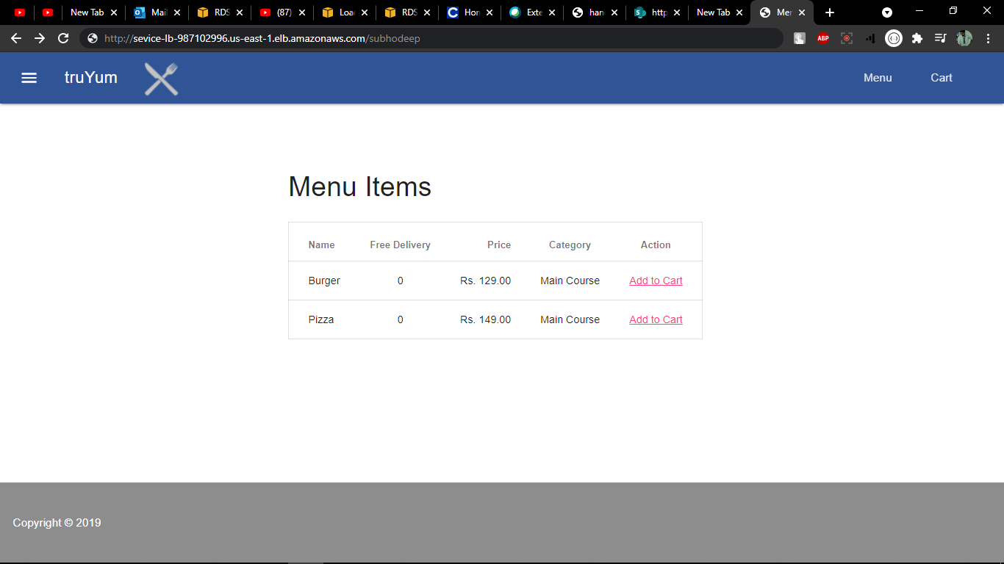

-----------------------------------------------------------THE END------------------------------------------------------------------